Fiber Arts Tutorial: Darning 101

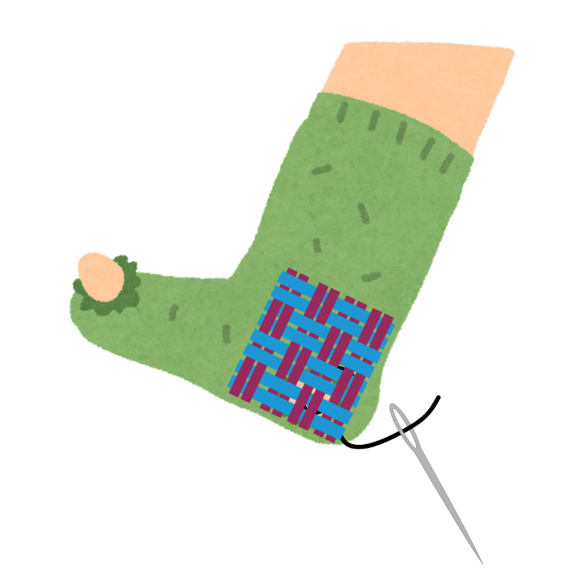
Prevent pollution and textile waste: learn how to mend a hole in your sock using the linen darning technique!

Materials needed:
- Needle
- Embroidery thread, sock yarn, or similar
- Scissors
- Sock with a hole
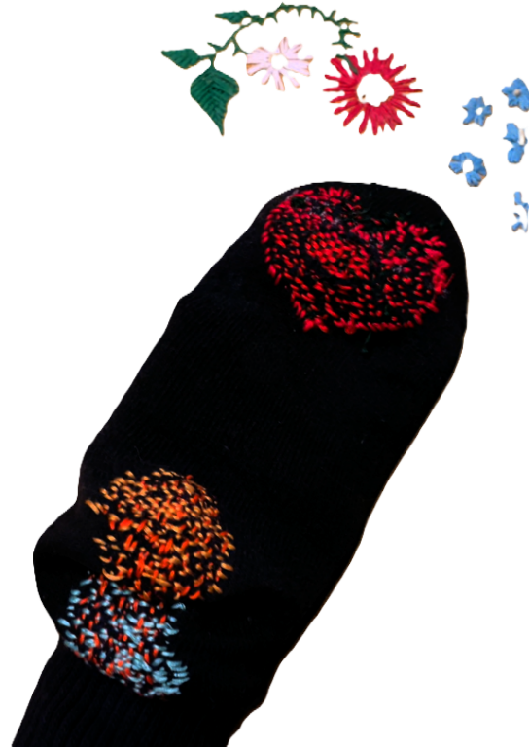
- Darning egg, darning mushroom or similar (dead lightbulb, plastic easter egg, etc.)
Skills you’ll learn:
- Tailor’s knot
- Running stitch
- Weaving
- Darning

Linen Darning: Mending a hole in your sock

- Turn your sock inside out and put your darning egg (or similar) inside against the damaged area.
- Thread your needle, leaving two tails, one short and the other long. Make a tailor’s knot with your thread at the end of the longer tail.
How to tie a tailor’s knot: Hold your needle and short tail in your dominant hand, and the end of your thread in your other hand with the long tail pointing down. Pointing the needle at the long tail end of the thread so that you are forming a circle, wind the thread around your needle 3-5 times. Grasp the thread wound around the needle with the thumb and forefinger of your dominant, holding it together with the short tail, and pull the needle and thread away from you. You should be left with a knot in the thread between your thumb and forefinger.
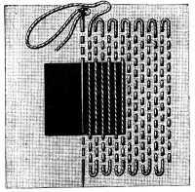
- Warp Threads: Insert your needle one or two centimeters away from the damaged area and bring it back out again a few millimeters above where you inserted it to create a running stitch. Create parallel rows of running stitches that extend 1-2 centimeters beyond the damaged area on all sides, in a square (or any other shape that covers the area!)
  - When you reach the end of each row, don’t pull your thread tight, but leave a small loop of thread.
  - The threads that run across the hole in your sock will be the warp allowing you to weave a patch of new fabric. Try to keep your rows close together! (The threads in the image are only drawn so far apart in the illustrations for clarity.)
- Once you have created rows of parallel stitches extending beyond the damaged area 1-2 centimeters on all sides, rotate your work 90 degrees.
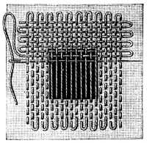
- Weft Threads: At the edge of your work, begin your weft threads, parallel rows of running stitches that are perpendicular to the warp threads, alternate weaving your thread over and under the rows of stitches in the warp.
Remember to keep your rows as close together as possible!
Get creative by using different colors of thread for your warp and weft!
- Once you’ve finished sewing the weft threads, knot your thread and trim any stray ends.
- Turn your sock right-side out and admire your work! Examine your sock for any other weak areas that might benefit from reinforcing and darn any other holes or threadbare areas you might find.
Video Tutorials:
- Linen Darning Video: https://youtu.be/0NBhgQr3b74
Key terms & vocabulary:
- Visible mending: Repairing clothing or damaged fabric to prevent waste by using intentionally visible techniques that embellish and add character to the item
- Linen darning: technique for mending a small hole in fabric where a patch would add inconvenient bulk to the clothing or material. Less visible mending technique where thread is used to reinforce or replicate the weave of the original fabric to mend the hole.
- Weaving: the craft or action of forming fabric by interlacing threads
- Running stitch: stitch made inserting the needle into a fabric and taking it out at small intervals
- Tailor’s knot: a knot used to secure stitching at the start and end of a seam that sits close to the fabric.
- Reuse: to use again especially in a different way or after reclaiming or reprocessing.
- Waste reduction: anything that reduces waste by using less material in the first place
- Pollution prevention: any practice that reduces, eliminates, or prevents pollution at its source

Additional Reading & Resources:
- Visible Mending: Repair, Renew, Reuse The Clothes You Love (By Hand), by Khounnoraj Arounna, ISBN: 1837830738
- Encyclopedia of Needlework, by Thérèse de Dillmont, ISBN: 9780448164540
Full text available through Project Gutenberg: https://www.gutenberg.org/cache/epub/20776/pg20776-images.html

