Tutorial: Cardboard Sculpture & Paper Clay

Use objects and materials that you can find anywhere to create sturdy sculptures, masks, furniture and more!

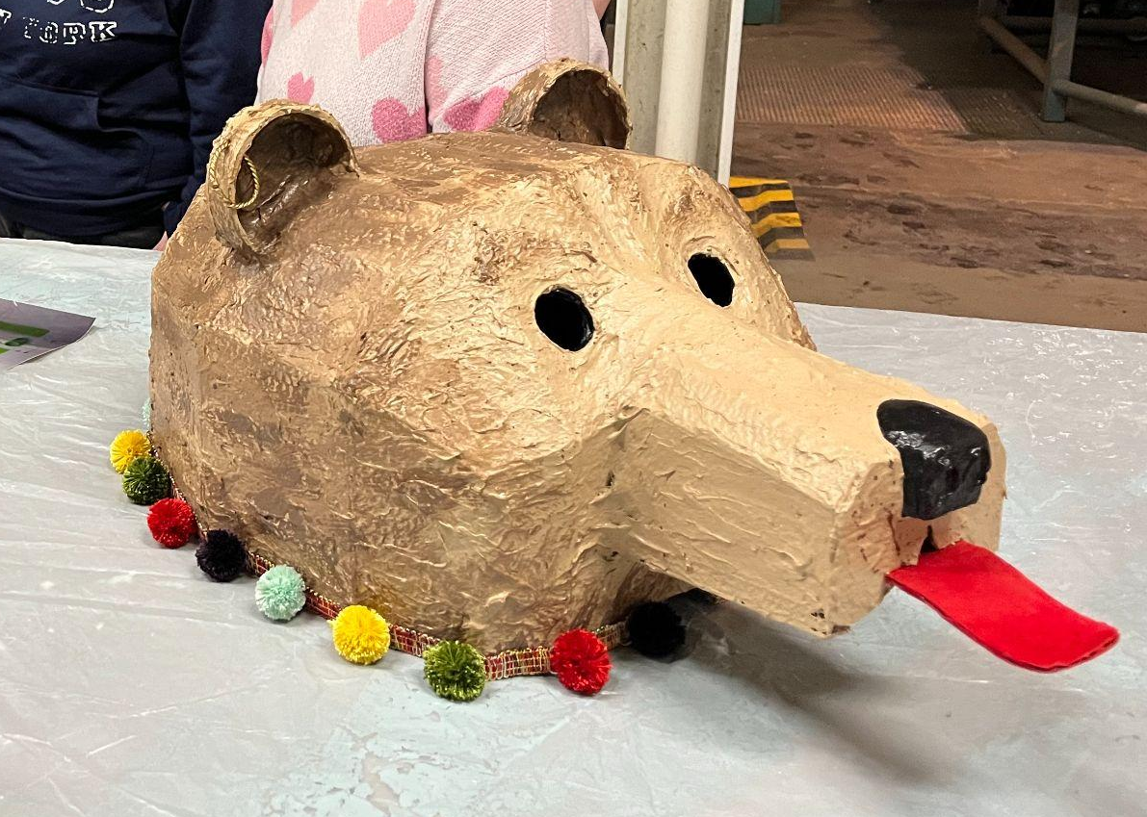

Materials needed:
- Cardboard
- Paper (newspaper, toilet paper, construction paper, or similar)
- Tub or similar container for making pulp in
- PVA Glue
- Drywall Compound (Recommended: a water-based joint compound such as SHEETROCK Brand Gallon(s) Bucket Premixed All-purpose Drywall Joint Compound– other brands may contain additional additives that will not work well for this purpose)
- All Purpose Flour
- Optional: Baby Oil
- Blender (or food processor, immersion blender, or similar)
- Colander or strainer
- Bowl
- Measuring cups
- Rubber spatula
- Hot glue
- Masking tape
- Clay tools for application and shaping (tongue depressors, popsicle sticks, toothpicks)

Skills:
- Paper pulp
- Paper clay:
  - Should stay workable for a couple hours
  - in an airtight container can stay wet and workable for weeks to months but may grow mold mildew
  - Put it in front of a fan or moving air, should dry within 48 hours enough to continue adding more layers if desired (drying time may change based on humidity and temperature, and size of the item)
- Cardboard construction & sculpture

Paper Clay Recipe:
1 ¼ cup paper pulp
¾ cup glue
1 cup joint compound
¼ - 1 cup flour
Optional: 1 tsp baby oil

Steps:
Make the paper pulp

- Tear paper into small pieces and soak it in water overnight* in a small tub or basin.
*Toilet paper will dissolve in about 20-30 minutes, so can be processed same-day.
Cardboard Construction:
- Using hot glue, masking tape, and pieces of cardboard, construct the base of your sculpture. The foundation created with cardboard will be coated with paper clay, like icing a cake, so avoid fine details and create shapes and textures in your sculpture with enlarged, simplified, or exaggerated shapes that will still stand out when coated.
Make the paper clay
- Scoop the paper water mixture into a blender or similar tool and blend it to create a uniform paper pulp.
- Strain the pulp using a colander or strainer until you have about 1 and ¼ cup of paper pulp that is not too wet or too dry. It should still stick to itself if you break it apart and press it back together.
- In a bowl, mix paper pulp, glue, joint compound, flour, and oil. Stir until all are evenly incorporated. Add more flour to reach a thicker consistency
Add clay to your cardboard sculpture
- Coat your sculpture tools in baby oil so that the paper clay won’t stick to them. Use the tools to apply the paper clay to your sculpture.
Finishing touches
- The clay will dry within 48 hours, after which you can add additional layers or finish your work by sanding and sealing it with a finish such as paint or polyurethane.

