Fiber Arts Tutorial:

Cereal Box Heart Basket
This is a fun introductory way to teach weaving and how to reuse common household materials to create art. In this tutorial, you will use a cardboard cereal box as a kind of loom to weave a basket.

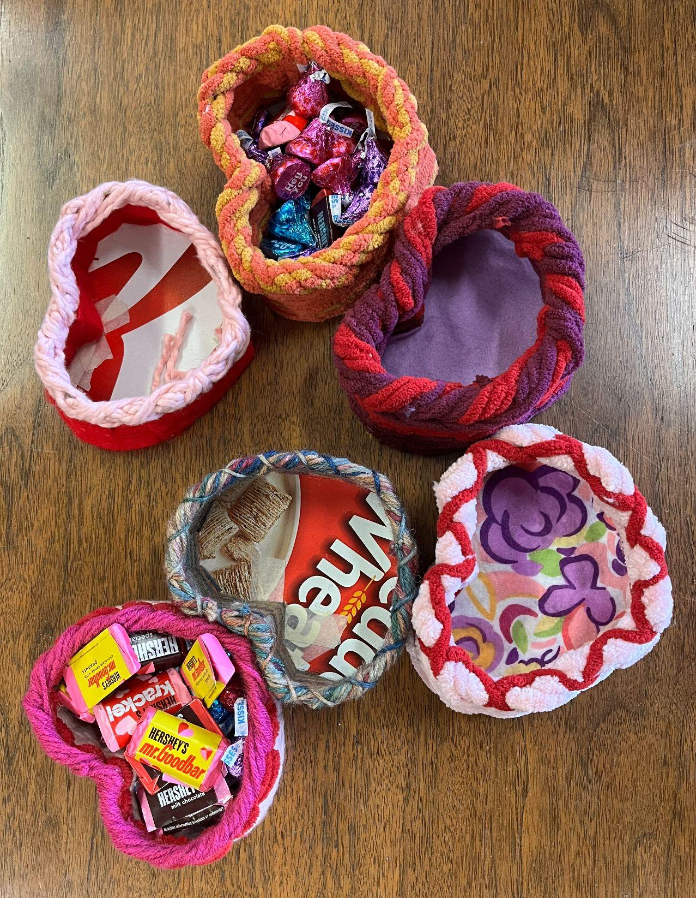
Materials needed:
- Heart basket template (attached)
- Cereal box
- Scissors
- Tape
- Pencil
- Hole punch
- Yarn needle
- Yarn
- Optional (for inner or outer lining): glue, fabric

Skills:
- Weaving
- Whip stitch
- Fabric decoupage

Steps:
- Making the cardboard loom: Using the template, trace the loom onto the cardboard and cut it out. Try to ensure that each spoke is the same length.
- Cut out the three extra spokes and tape them onto the blank spaces at the top of the heart.
- Using the hole punch, punch holes in each spoke about half a centimeter from the edge.
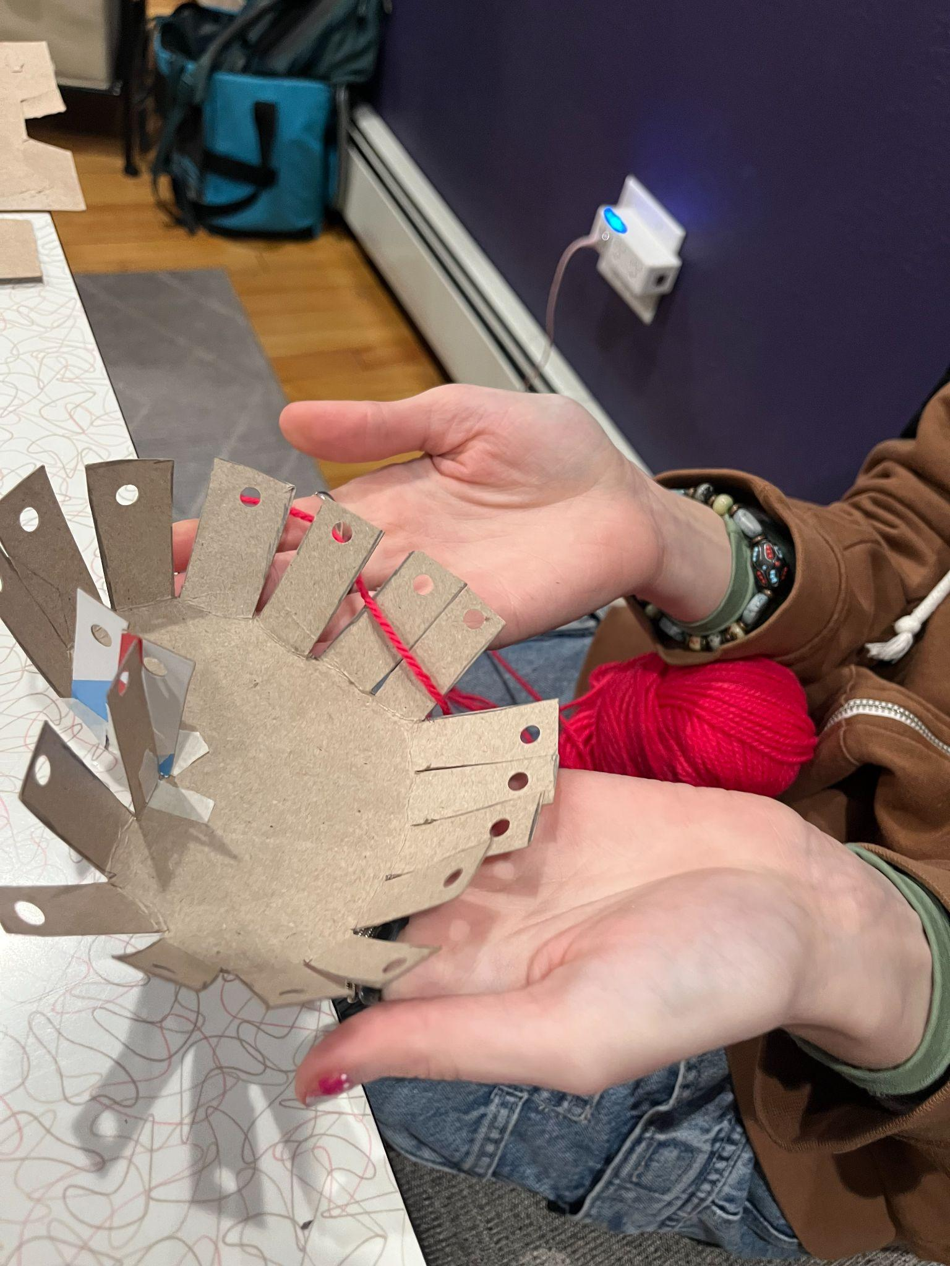
- Fold all the spokes of your loom inward so they are standing up.

- Add a Lining (optional): Decide if you want the bottom of your basket to show the design on your cardboard, or if you would like to add a fabric lining. At this stage, you can cut out and glue a piece of fabric to the bottom of your basket before you begin weaving.
- Begin Weaving: Take the end of your yarn and tie it to the bottom spoke of the heart, or tuck it securely between two spokes while you begin weaving
- Weave the yarn over one spoke and under the next, continuing this pattern around your loom. The first couple times around are the trickiest!
- Keep going over and under each spoke as you go around and around. Because there are an odd number of spokes on the loom, you will notice that the yarn alternates going under a spoke on the first time around, over it on the second time around, under it again on the third time around, and so on.
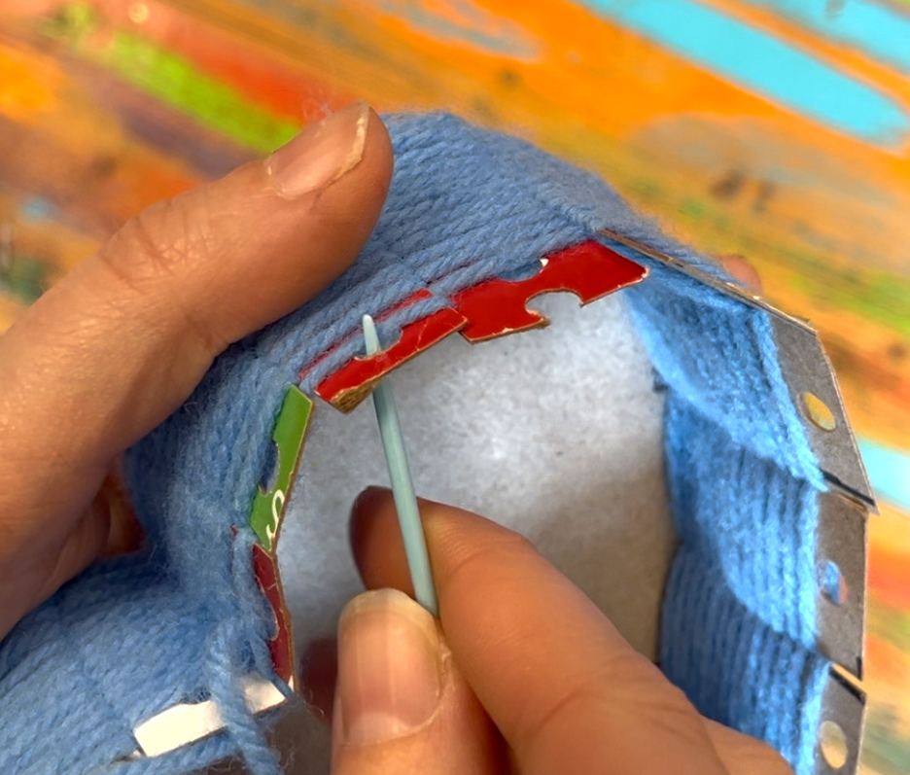
Tips: Try not to pull your yarn too tightly or it will bow the sides of your basket inward. As you weave, you can push the yarn down to ensure that it is covering the cardboard. Use different colors to create stripes or patterns!

- When you reach the holes you punched in the spokes, cut your yarn to an arm’s length and thread the end through your yarn needle. To finish the basket, you can create a border by whip stitching around the edge.

- Insert the needle from the inside of the basket out through the hole closest to where you left off. Pull the yarn all the way through.
- Skip the next hole, and again insert the needle from the inside of the basket through the hole and pull your yarn all the way through. Continue like this all the way around, several times. This will create a winding edge to cover the cardboard at the top of the basket.
- When you are finished, you can weave in the ends of your yarn (insert the yarn over and under other stitches to secure it).
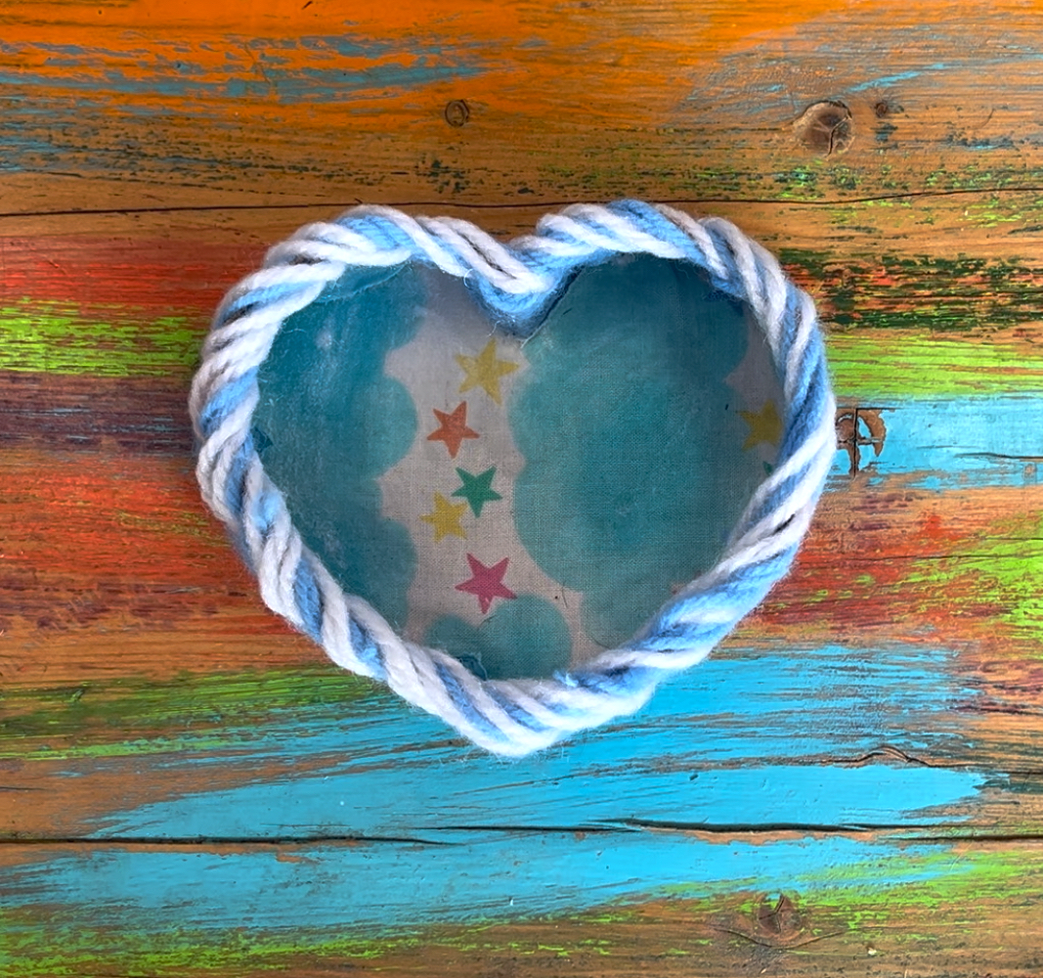
Key terms & vocabulary:
- Basket Weaving: the process of weaving or sewing pliable materials into three-dimensional artifacts, such as baskets, mats, mesh bags or even furniture.
- Whip stitch: a kind of overcast stitching technique created by wrapping thread around the edge of the work
- Reuse: to use again especially in a different way or after reclaiming or reprocessing.
- Waste reduction: anything that reduces waste by using less material in the first place
- Pollution prevention: any practice that reduces, eliminates, or prevents pollution at its source

