Tutorial: Plastic Bag Coil Basketry

Use plastic bags and scraps of yarn to create functional upcycled baskets, mats, bags, and more!
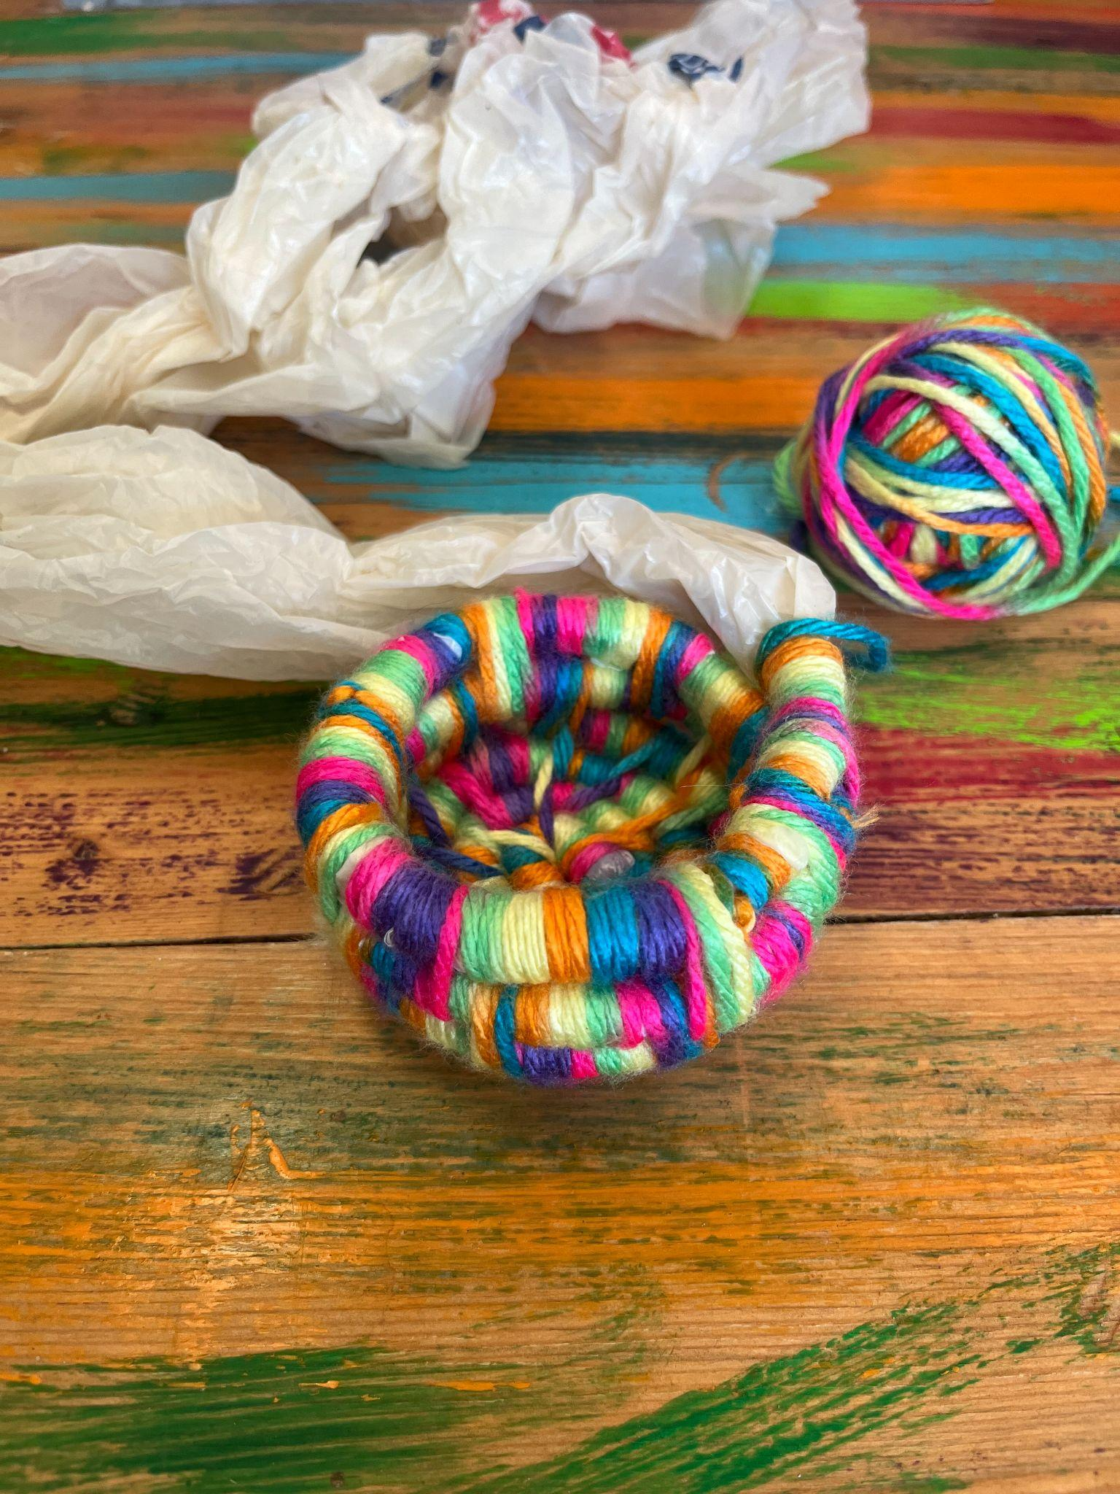

Materials needed:
- Plastic bags
- Yarn
- Yarn needle
- Scissors
- Tape (optional)

Skills:
- Spiral coil basket technique

Vocabulary:
Upcycle: reuse (discarded objects or material) in such a way as to create a product of higher quality or value than the original
Basket: a container used to hold or carry things, typically made from interwoven strips
Core: the basis structure on which the basket is built. In this example, we are using a plastic bag as the core
Coil: yarn (or other material) that is wrapped around a core and then sewn in an orderly manner

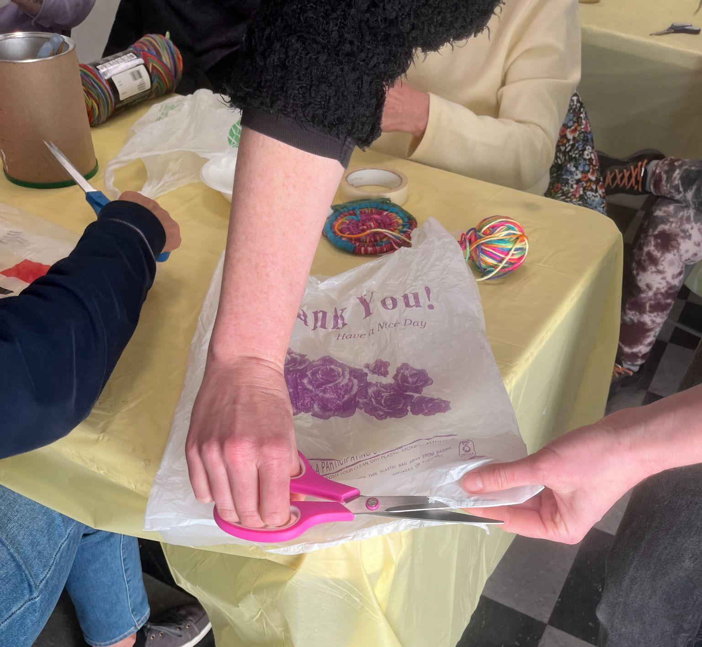

Steps:
- Using a plastic shopping bag, create one large rectangular piece of plastic by cutting open the seam at the bottom and one of the sides.

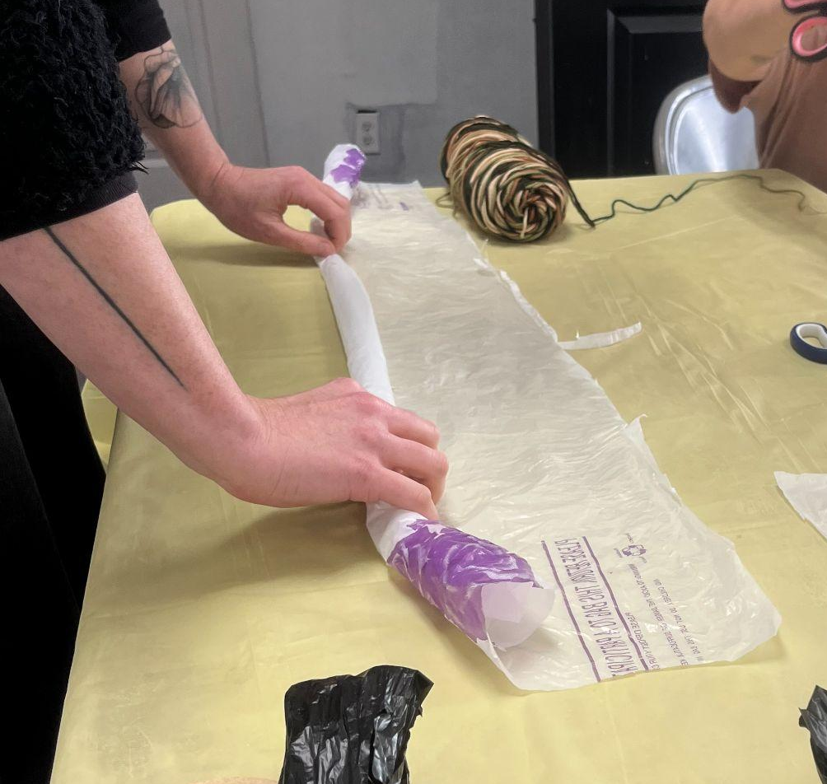
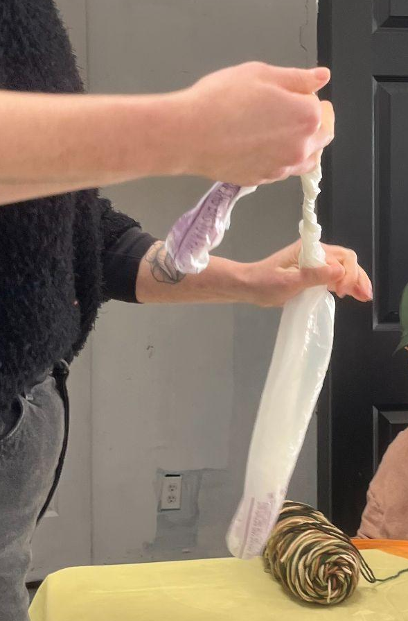

- Roll the plastic up to form a long tube. Twirl the tube and apply tape at intervals to form a long plastic cord. This is the core of your basket.

- Tie your yarn to your plastic bag core, about 1 inch from the end.
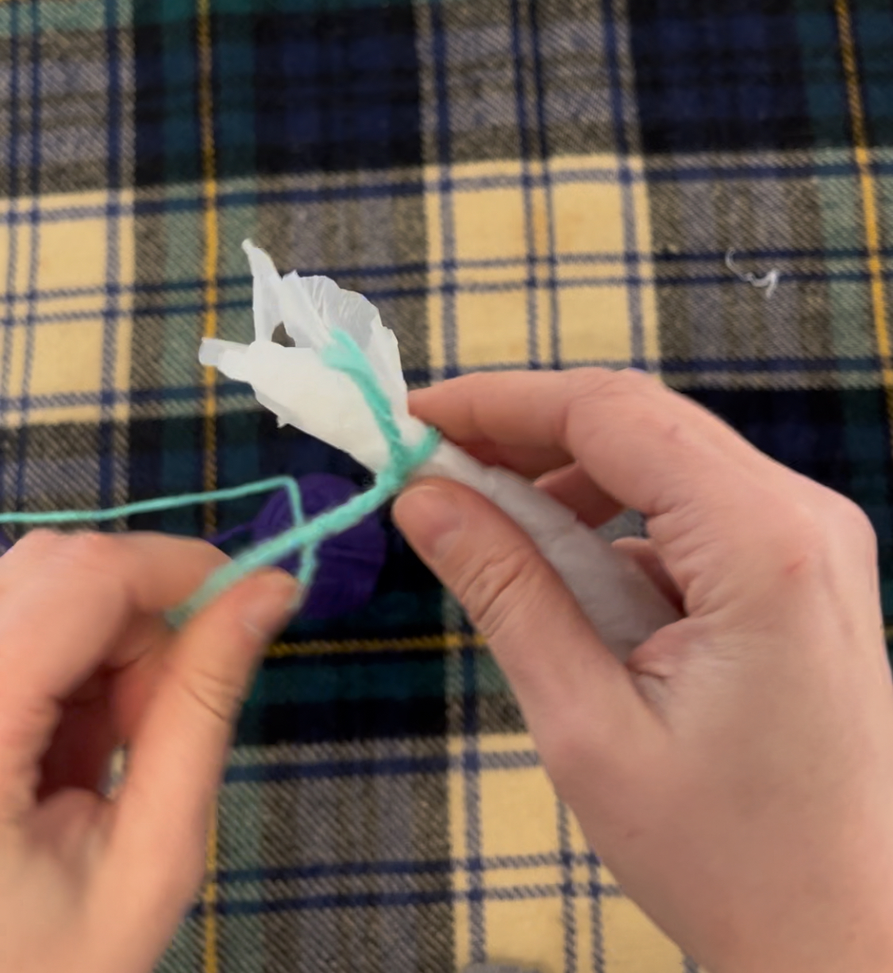
Before you begin coiling:

Plan your stitch pattern! You will be winding yarn around the core and then binding the coils of the basket together with stitches at regular intervals. In this example, we will be winding the yarn 10 times around between stitches.

Begin Coiling

- About 1-2 inches from the end of the core, wrap the yarn around about 10 times, in the direction of the end of your core.

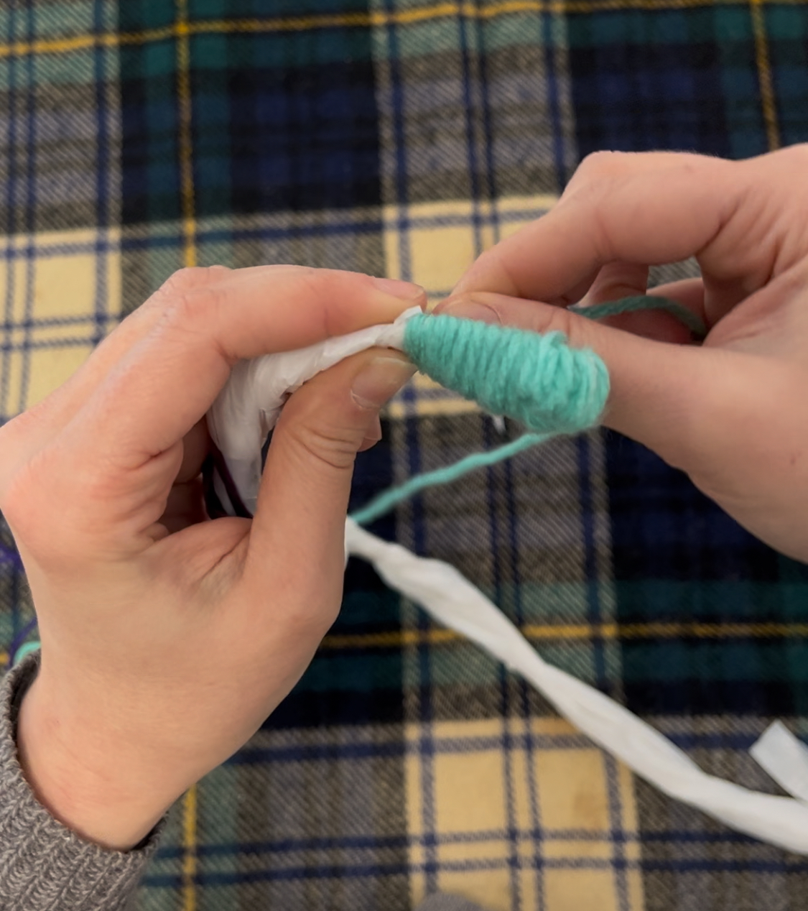
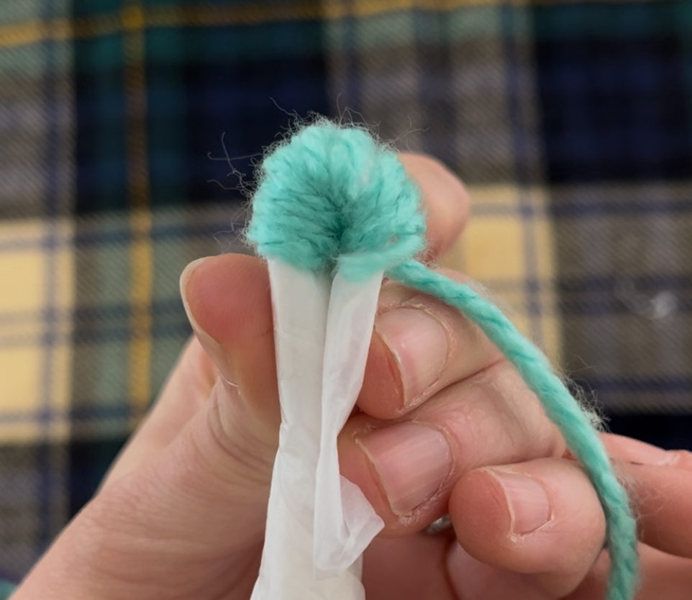
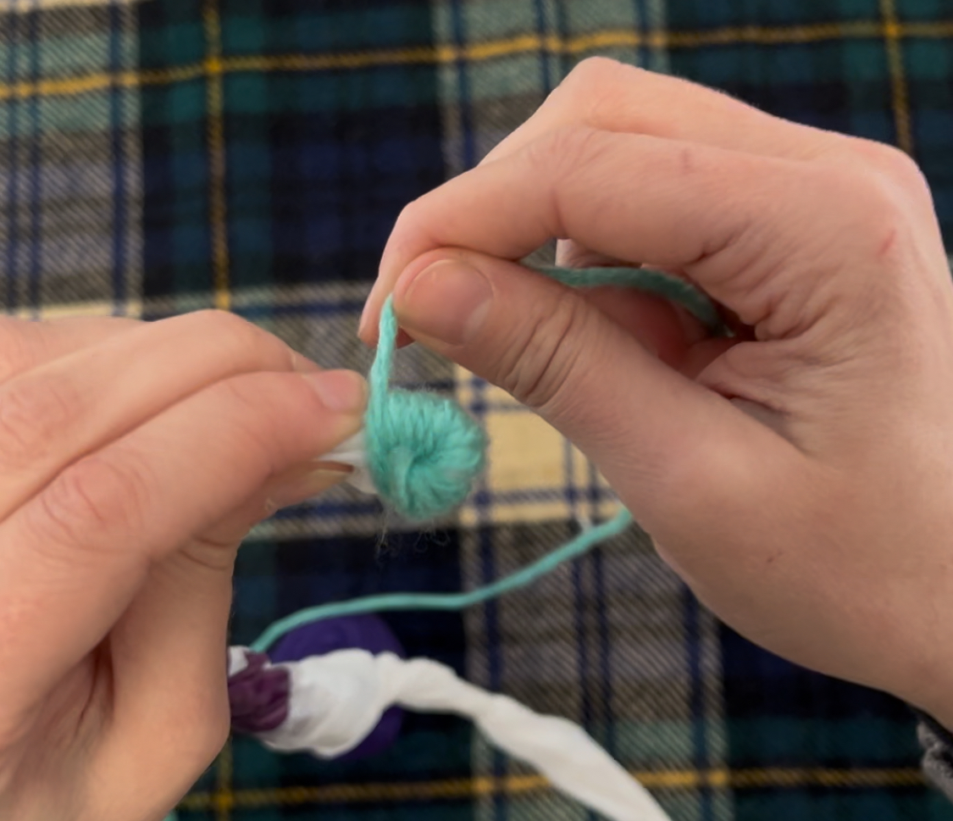
- Fold this section in the middle, then bind the end of your core to itself by winding the yarn around both and wrapping them together. This is your starting line.
- Cut your yarn at an arm’s length from your starting line, and thread your yarn needle. Move your needle to the end of the yarn, leaving a tail about 2 inches long.
- Make your first stitch: Coil your starting line (bend it inwards to create a circle) to begin creating your first loop.
  - Pierce your yarn needle through the center of the work, and pull it through.
  - Pierce your yarn needle through the last stitch on your core,
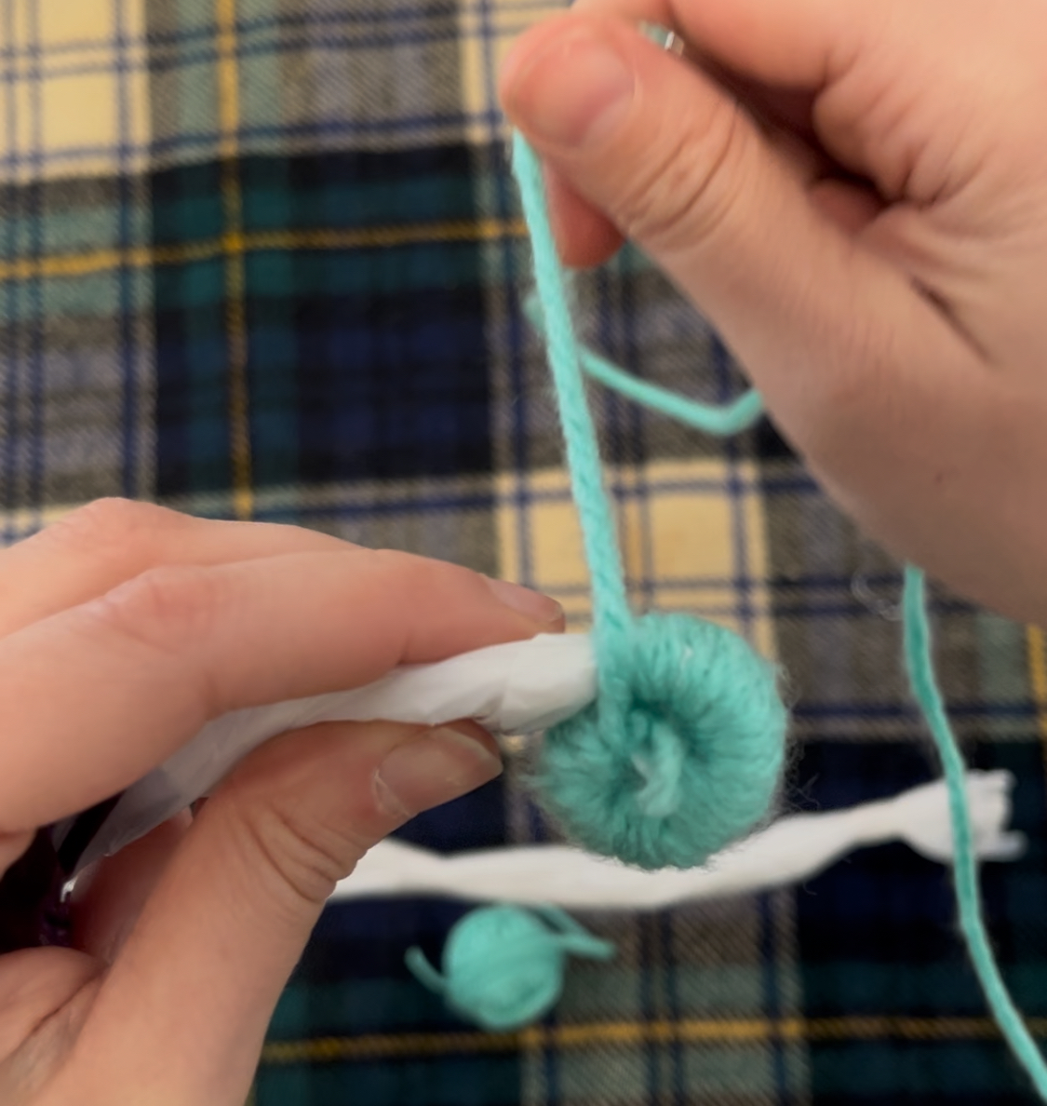
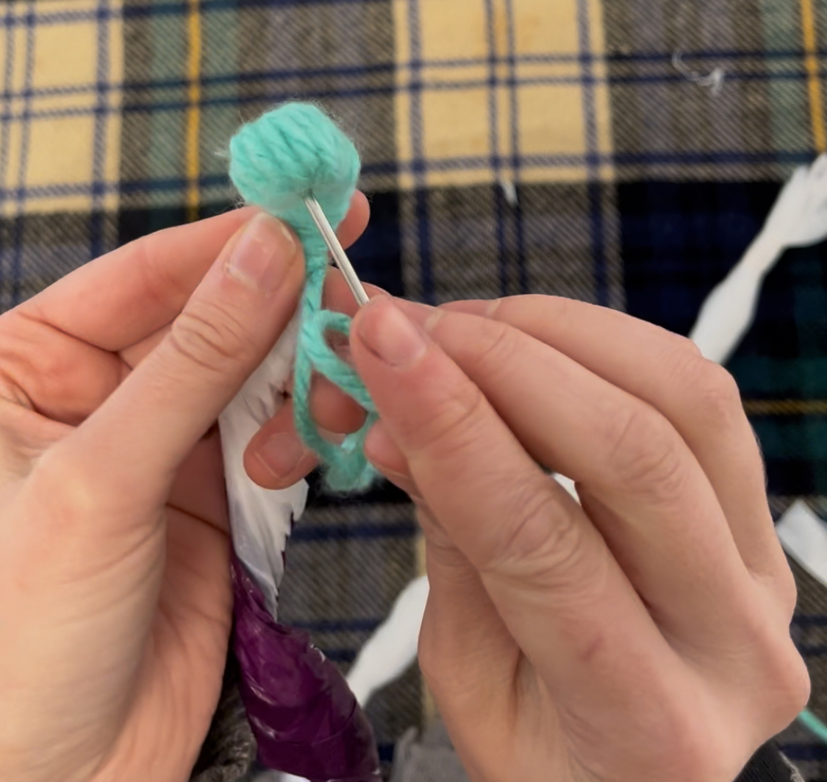
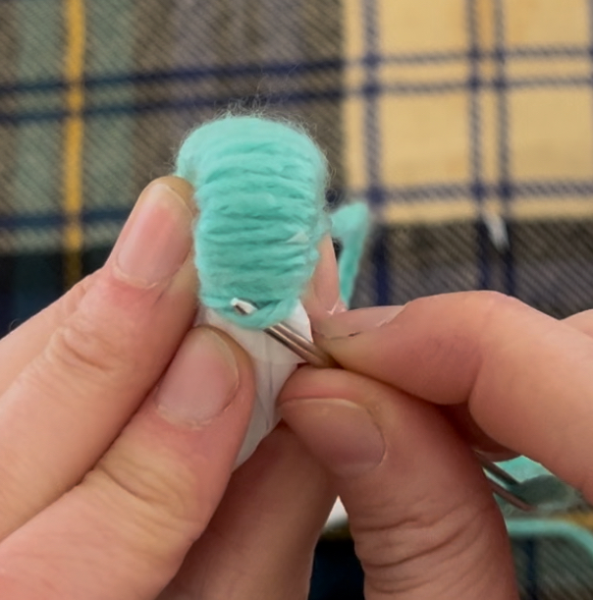
  - Pull the yarn taut. This creates a stitch that stabilizes your work and holds the loops of your basket together.
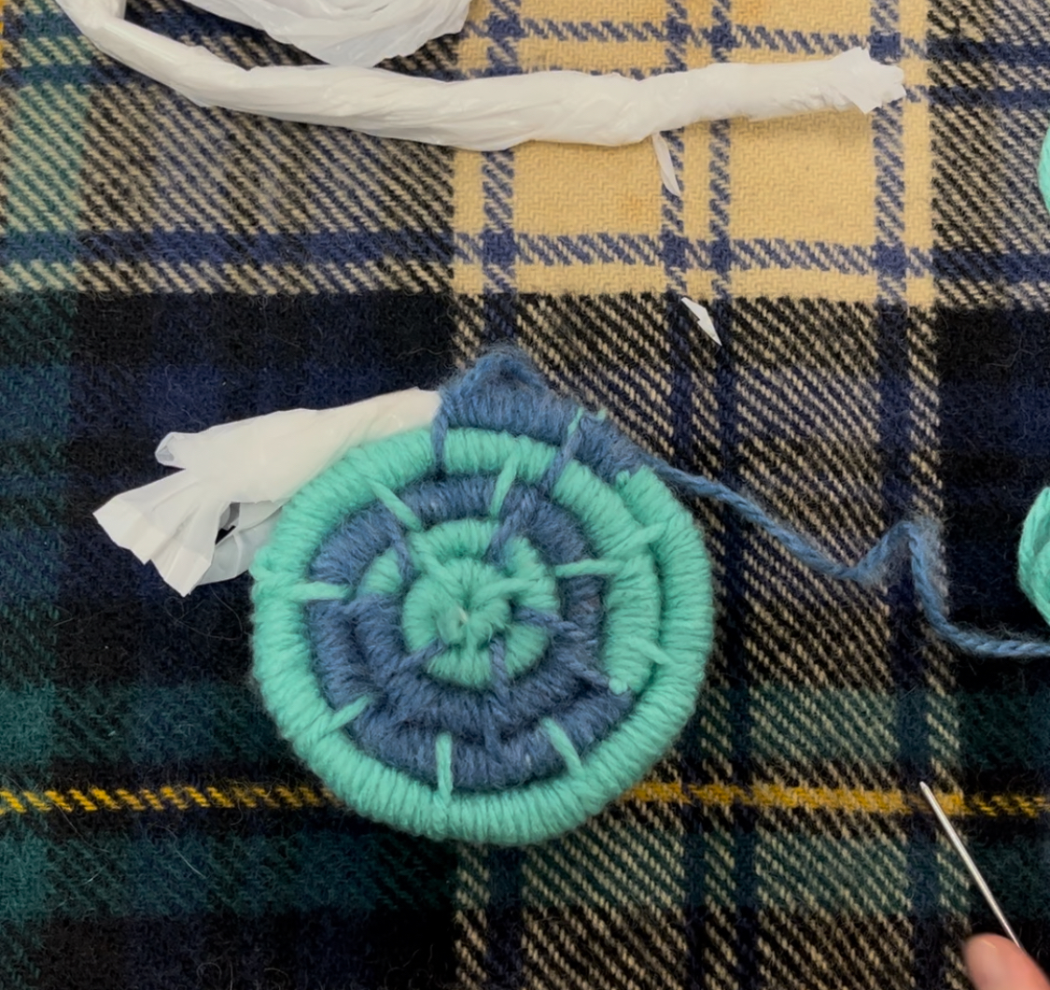
- Wind your yarn around the core 10 times, then repeat step 8 to create another stitch
- Repeat step 9 to create a 3rd stitch. At this point, you should have come full circle and you are now creating the next loop. Wind your yarn around 10 times, and for your next stitch, instead of pulling your yarn through the center, pull your needle through the last loop to bind it to the loop you’re working on. Continue to coil and stitch to secure each loop to the one before it.
- Continue to coil and stitch until you are 2-3 inches from the end of your plastic bag core. You can tie new yarn to the end of your working yarn whenever you run out or if you want to change colors to create a pattern.

- When you are ready to splice another plastic bag onto your core, open up the end and tuck the end of your next plastic bag core into it. You can tape them together to secure them, or simply hold them together until you have coiled enough yarn around them to hold the ends together.

Changing colors: Thread your yarn needle on the new color. Tie your two ends together. Cut the new yarn to your desired length and move the yarn needle to the end. It is easiest if you then leave the needle on the table until you need it for stitching later.

Tips for coiling: Hold your plastic bag core with your nondominant hand, and tuck any ends of the yarn where you tied it under your thumb. With your dominant hand wind the yarn around the core, hiding the ends of the yarn where it is tied.

Finishing your basket: When your basket has reached the desired shape and size, you are ready to finish. On the last 1 inch of your core, create a series of stitches in a row, coiling your yarn around the end of the core and your last loop for at least 5-10 consecutive stitches to secure it to the basket edge. Tie a knot in the last couple of stitches to secure the end of your yarn, and use your yarn needle to tuck the knot and any loose ends underneath your stitches.

There are many more ways to make or finish a coil basket! Learn more from the readings listed under additional resources.

Additional Resources:

- It's a Wrap: Sewing Fabric Purses, Baskets, And Bowls. By Susan Breier. ISBN: 156477662X; ISBN13: 9781564776624
- How to make coiled baskets using jute, synthetics, yarns. By George Smith. ASIN ‏ : ‎ B0006Y57ZI
- ADVANCED COILED BASKETRY: Innovative Techniques for Creating Stunning and Unique Baskets. By Joshua Donna. ISBN: B0DQJ73R2M; ISBN13: 9798303697065
- The Material Culture of Basketry: Practice, Skill and Embodied Knowledge. ISBN: 1350359904; ISBN13: 9781350359901

