Tutorials: Found-Object Mosaics

Found object mosaics are a fun way to use traditional mosaic techniques to create a work of art using non-traditional materials, such as broken ceramics, mirrors, glass, shells, stones, or pieces of metal like bottle caps.

Materials needed:
- Personal protective equipment:
  - Safety goggles
  - Cut resistant gloves
- 12x12 piece of cement board, tile backer board, or other similar substrate
- Tile adhesive
- Tongue depressors or similar tool for spreading the adhesive
- Found objects
- Optional: hammer, glass cutter
- Grout
- Dish sponge, towels, toothpicks

Step 1: Tile Adhesion
- Choose your tiles and arrange them in the desired pattern on your cement board. You may want to take a picture of your arrangement to refer back to as you will need to take this apart as you adhere the tiles.
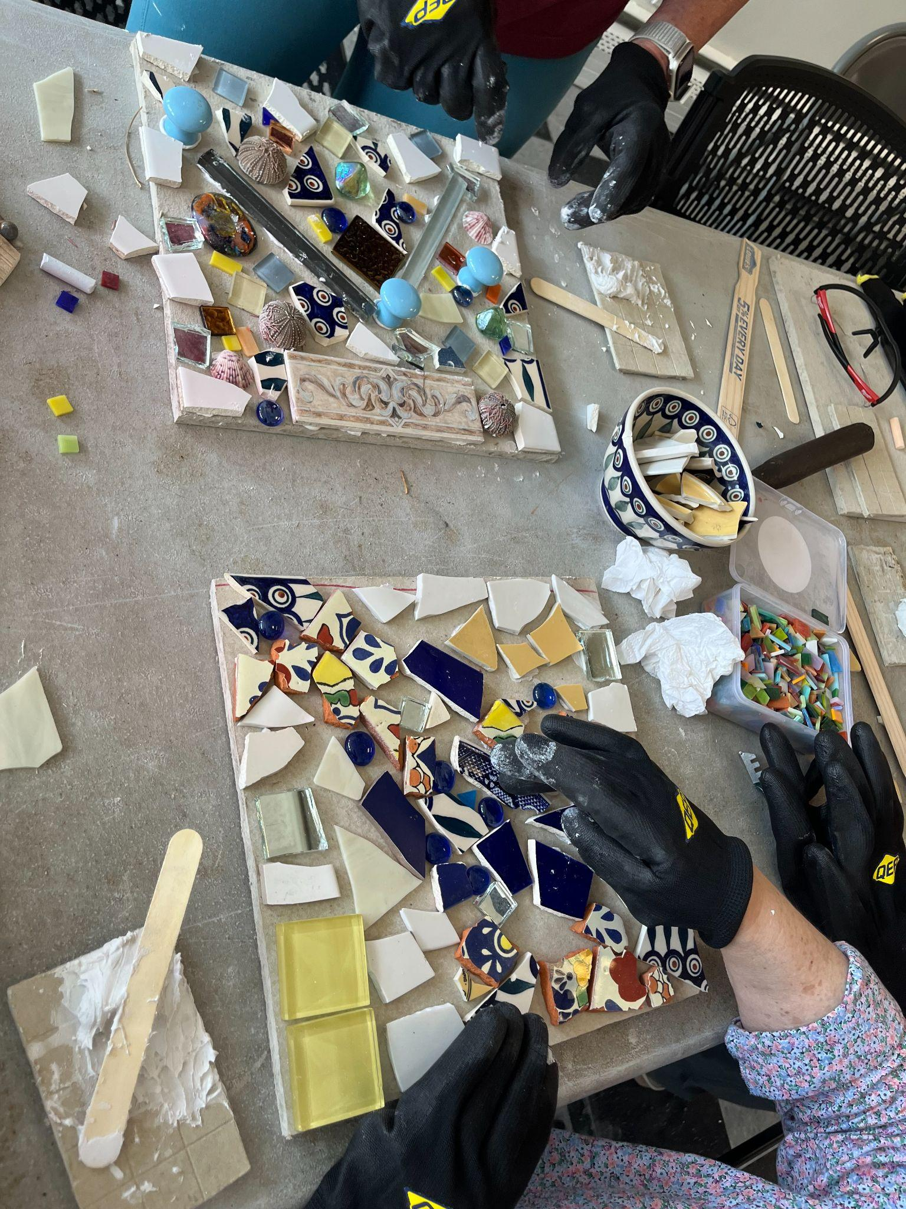
- Use a glass cutter or hammer to carefully break any larger pieces as needed. Make sure you wear your PPE to protect yourself from sharp edges or flying pieces!
- Put about a quarter cup of tile adhesive on a palette-like surface such as a small piece of scrap wood to make it easier to work with.
- Using the tongue depressor, take a small amount of tile adhesive and scrape it onto the tile, creating a roll of adhesive along the length of the tile.
- Press the tile onto the backing board, with the edge that has the adhesive on it first, pushing it forward as you press it down, which will evenly spread the adhesive onto the rest of the back of the tile as you do so.
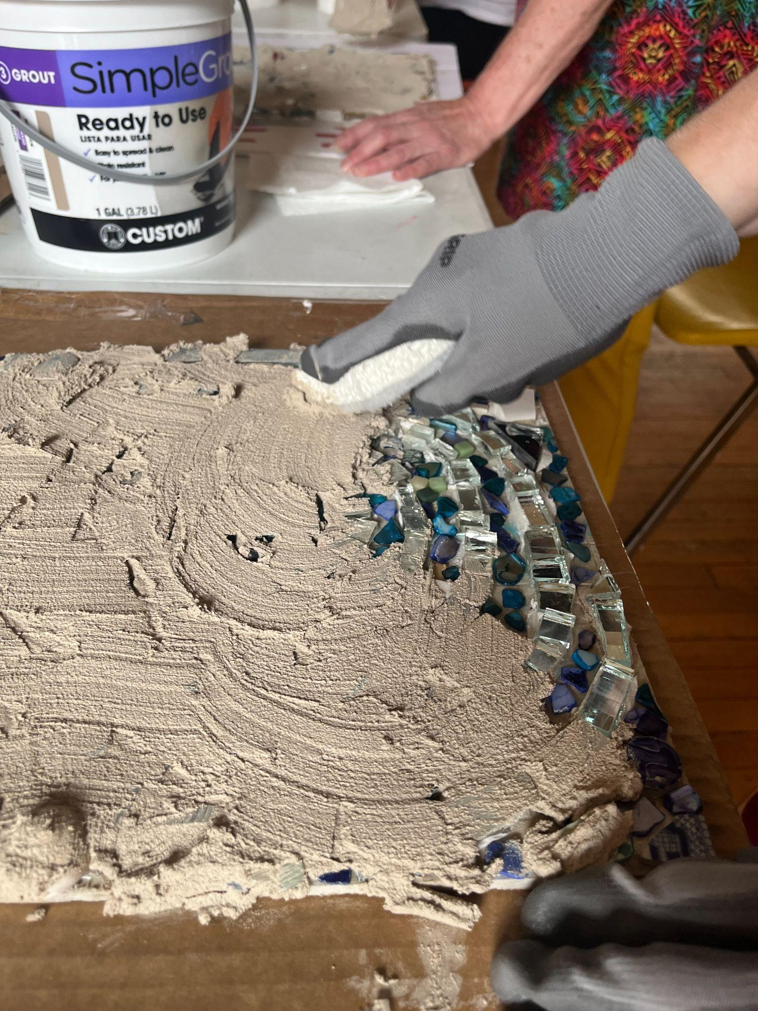
- Continue to apply your tiles in this manner until you have finished your design, leaving a small amount of space between each tile. If you pack your objects or tiles too closely, the work will be difficult to grout. If you leave too much space between tiles the grout may come loose more easily. If you’re not sure how much space to leave, aim for about 1/8th of an inch between each tile.
- Allow the work to dry flat for 24-72 hours (depending on humidity) so that the tile adhesive can dry completely.

Step 2: Grouting

- Mix your sanded grout with water in a small bowl to achieve a thick consistency like peanut butter.
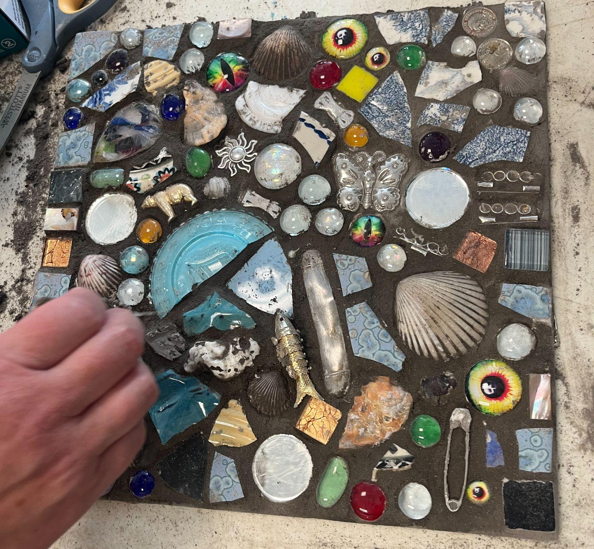
- Apply the grout over the entire work, ensuring to work it all the way into the spaces between the tiles.
- Using the soft side of a dish sponge, begin working to clean the grout off of each tile (leaving the grout in between the tiles!). You can use tools like toothpicks to clean grout out of small areas of found objects, like the ribs of a shell, and towels to shine and clean residue off of your tiles.
- Let your work sit for another 24-72 hours to dry fully

Additional Resources:
- Mixed-Media Mosaics: Techniques and Projects Using Polymer Clay Tiles, Beads & Other Embellishments, By Laurie Mika
- Making Bits & Pieces Mosaics: Creative Projects for Home and Garden, By Marlene Hurley Marshall
- The Complete Pebble Mosaic Handbook, By Maggy Howarth
- Philadelphia Magic Gardens: https://www.phillymagicgardens.org/events/workshops/

