Tutorial: Replace a Lamp Cord

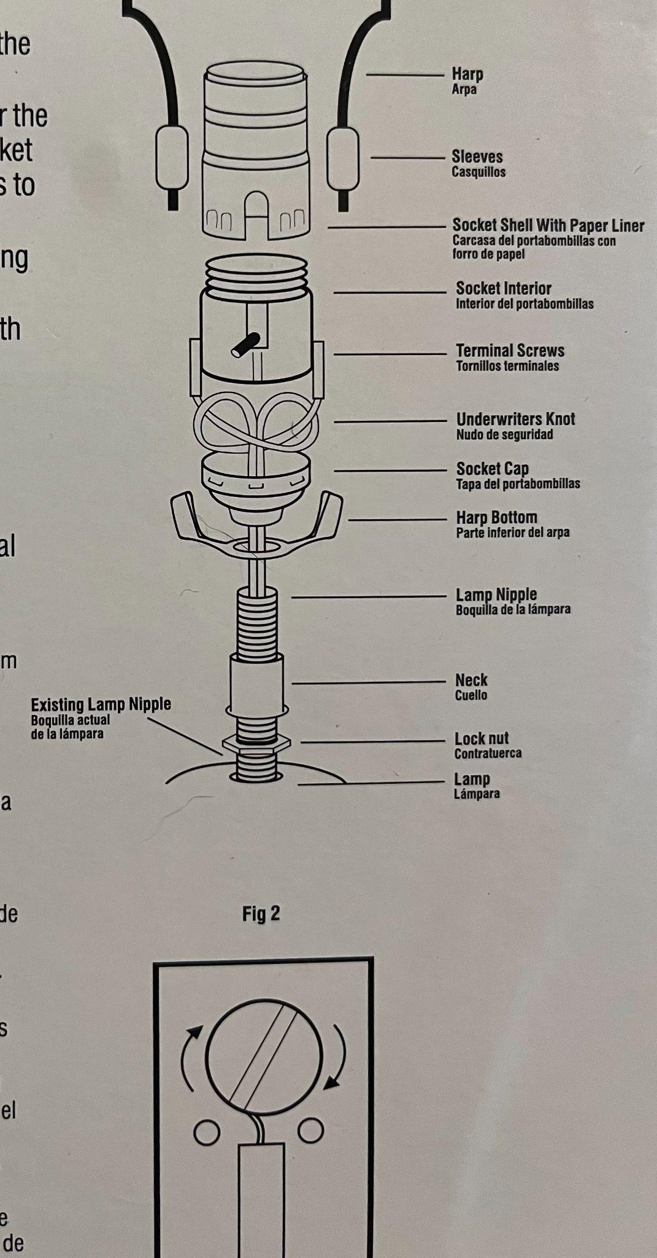
If the plug or cord on your lamp is damaged, you can easily replace it!

Materials needed:
- Lamp wire with a plug at the end (or a Make-a-Lamp-Kit which includes a lamp cord, socket, and other lamp hardware)

Steps
- Unplug your lamp
- Remove the lightbulb and lampshade
- Gently pull the interior socket out to expose the terminal screws. You may need to remove any covering securing the lamp cord at the bottom of the lamp to loosen the wire making it easier to pull the interior socket loose.
- Unscrew the terminal screws on either side to remove the old lamp wire, and pull it out through the bottom of the lamp.
- Insert the new lamp cord through the bottom of the lamp, pushing it through until the wires come out the top. Pull the wires apart as needed so that you can tie a new underwriter’s knot in the cord before attaching the wires to the terminal screws.
- Identify the neutral conductor by the ribbed cord. Wrap the conductor wire around the silver terminal screw clockwise, and tighten with a screw driver.
- Wrap the other conductor around the brass screw and tighten clockwise.
- Reinsert the interior socket into the lamp, and adjust the cord as needed.
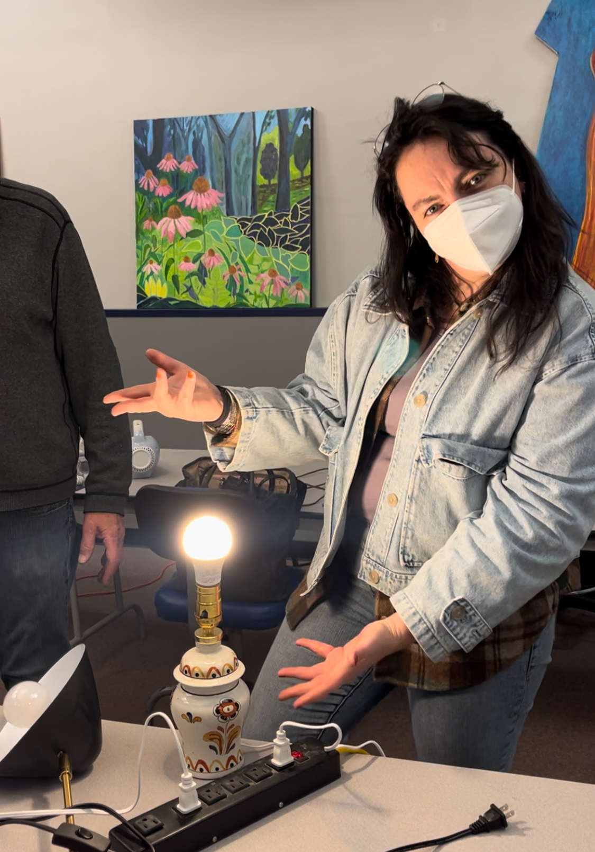
- Replace the lightbulb, plug your lamp into a surge protector, and switch it on!

