Scrappy Ornaments
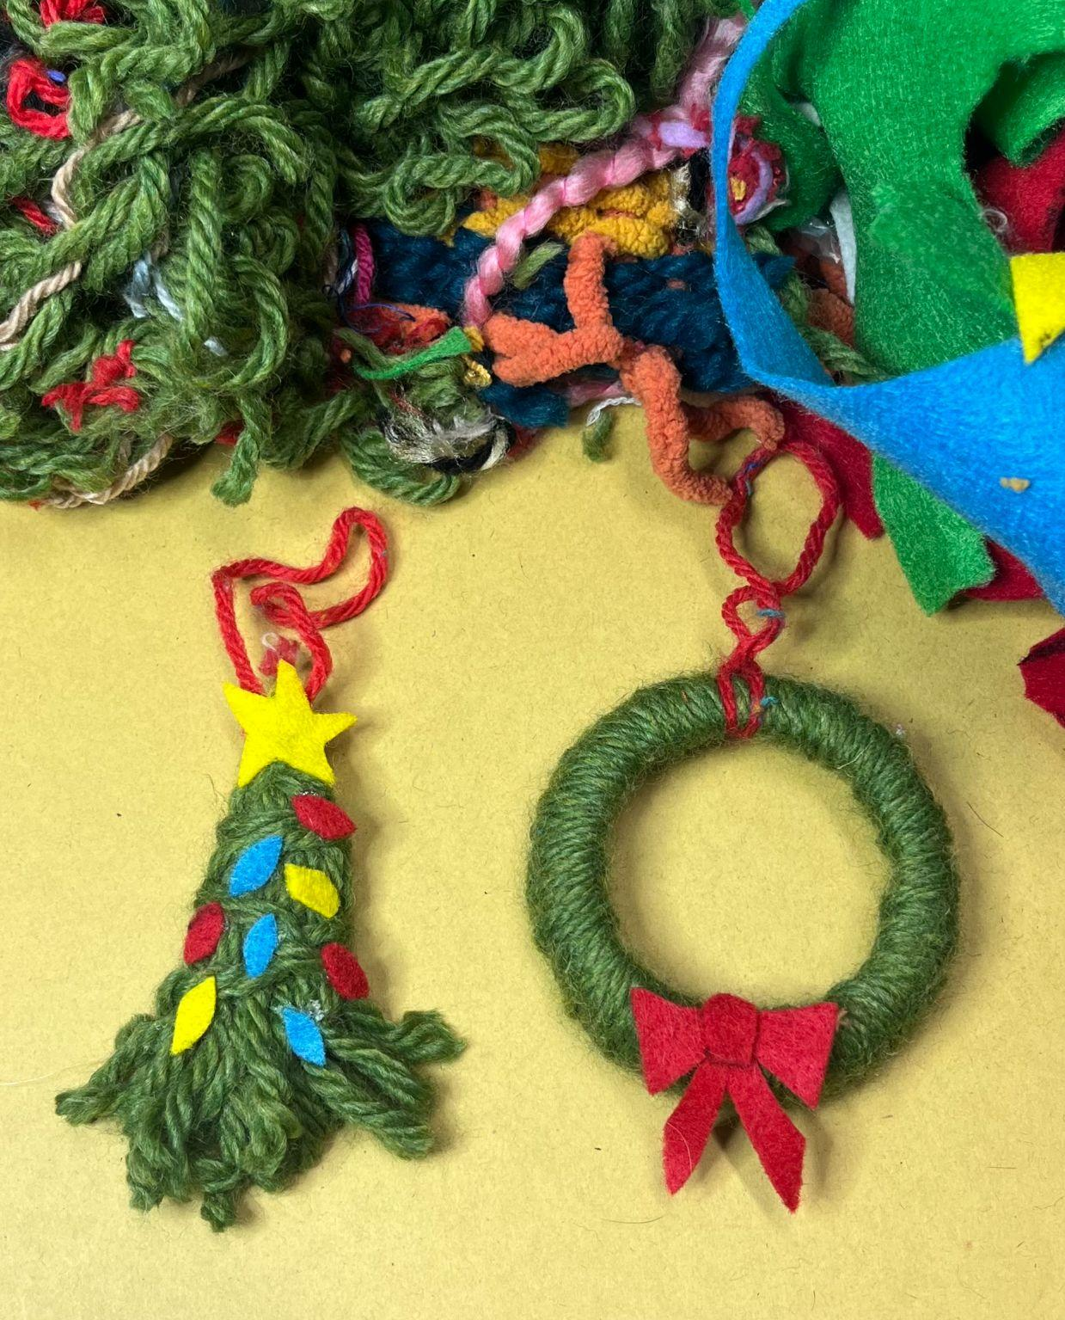

Reuse the odds and ends of your scraps of fabric, yarn, thread, felt, or other fibers to create holiday ornaments!

In this example, create a small wreath by upcycling a mason jar ring.

Materials needed:
- Fiber scraps– yarn, thread, fabric, felt, lace, ribbon, or other
- Mason jar ring or refillable ornament
- Hot glue gun

Steps
- Glue the end of your yarn to the inside of a mason ring.
- Wrap the ring with yarn until you can no longer see metal peeking through!
- Secure the end of your yarn with hot glue.
- Get creative: Use scraps to embellish your miniature wreath with bows or ornaments! Play with different colors and textures to create different effects.

