ANNUAL REPORT
March 1, 2024 - March 31, 2025

Utica Creative Reuse
Incorporated October 2023

Board Members
Elissa Johnson Christina Fliege Christian Jones
Executive Director Sarah Swann

uticacreativereuse.org uticacreativereuse@gmail.com

Our Mission
Utica Creative Reuse is a 501(c)(3) nonprofit dedicated to promoting creativity, community, and environmental stewardship in Central New York.

Our mission is to divert usable materials from the waste stream and return them to the community through an art supply thrift store and makerspace, as part of a circular economy. Proceeds from our thrift store support accessible and inclusive arts programming for all, empowering our community to connect through creativity.

We are committed to being a catalyst for equity, diversity, and sustainability in the arts by fostering an inclusive space for creativity, education, and dialogue. We are dedicated to inspiring people of all ages and abilities to embrace sustainable practices and build cross- cultural connections, working together towards a more resilient community.

Utica Creative Reuse uticacreativereuse.org

Our impact
Materials Diverted from the Landfill
March 1, 2024 - March 31, 2025
All Time Total:

3,795

Pounds of materials diverted from the waste stream

6,361
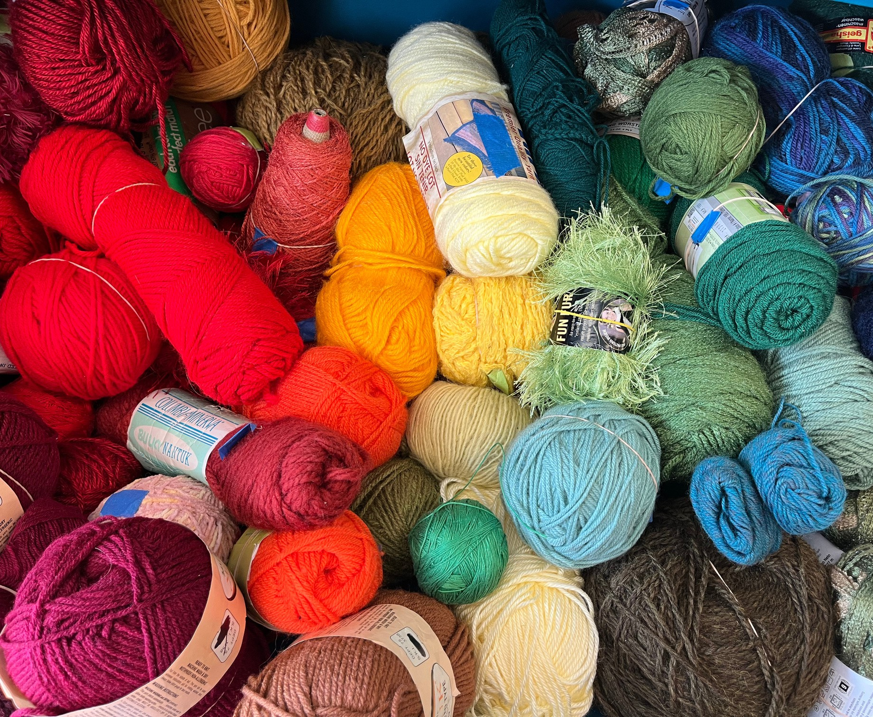
Pounds of materials diverted from the waste stream since September 2023

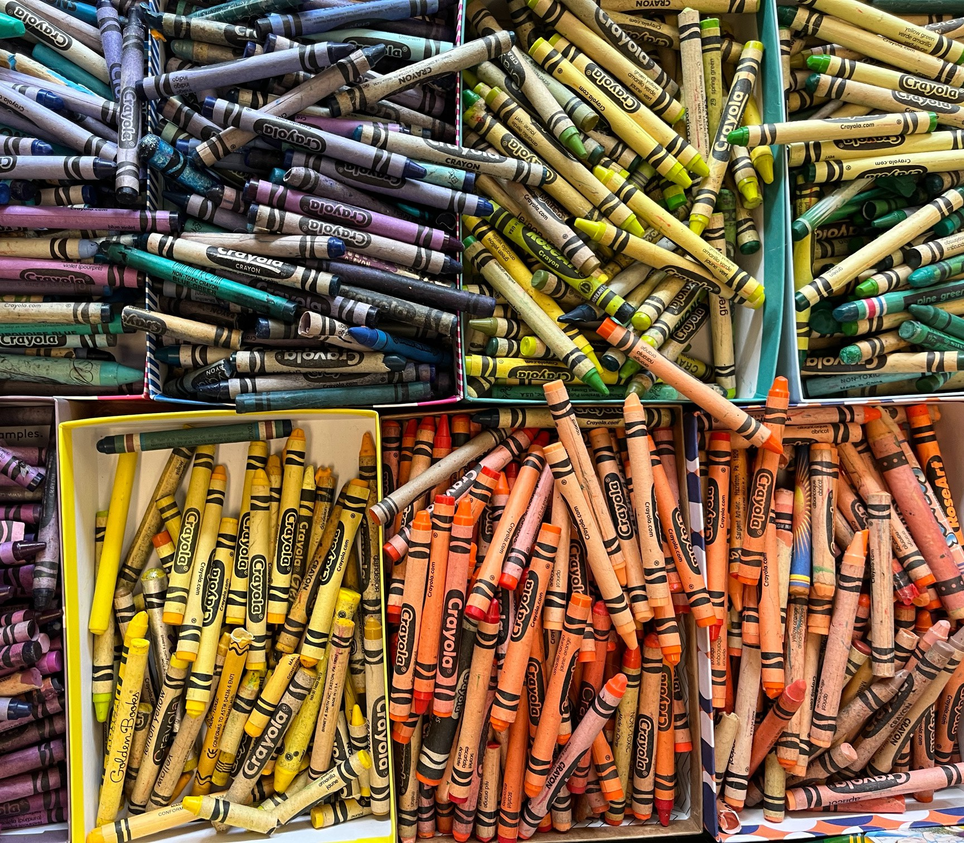

Waste Not, Want Not!
We ask members of our community to donate their unwanted arts and crafts materials and supplies to our thrift store and free events instead of throwing them away, so that we can help them find new homes.
This year, with your help, we diverted 3,795 pounds of usable materials from the landfill!

Utica Creative Reuse uticacreativereuse.org

Our impact
Events
March 1, 2024 - March 31, 2025

2,039 73
Event Attendees Events
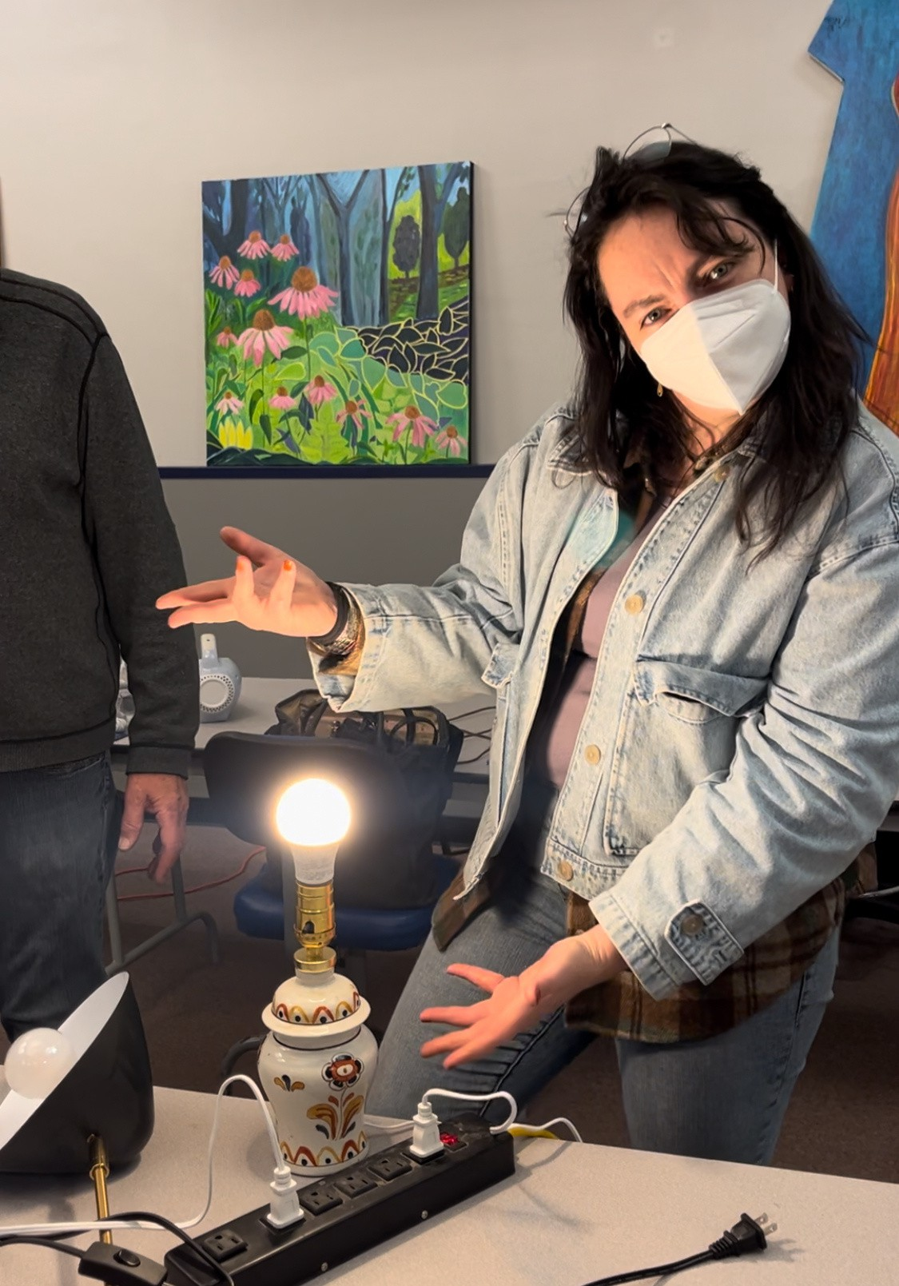
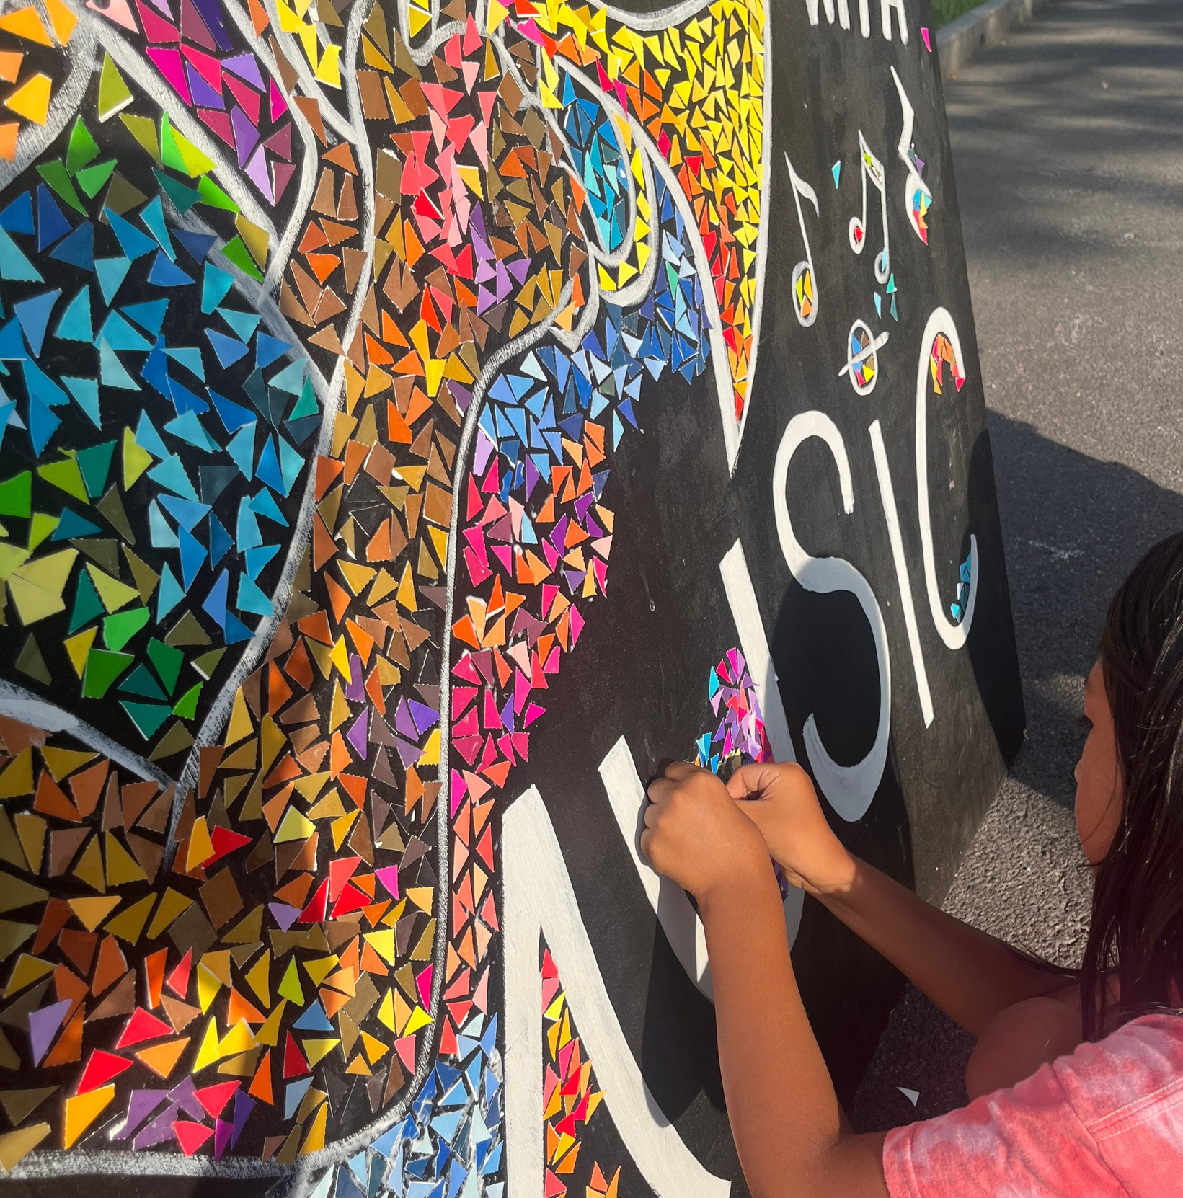

Creative Reuse is For Everyone!
Our events provide a supportive environment for learners of all ages to explore new skills in classes and events focused on reuse, repair, and creativity!

Utica Creative Reuse uticacreativereuse.org

Our Year in Review: March 2024 - March 2025

Trash to Treasure Art Challenge & Earth Day Cleanup
In April 2024, Utica Creative Reuse founder Sarah Swann received grant funding through CNY Arts to host the first Trash to Treasure Art Challenge and
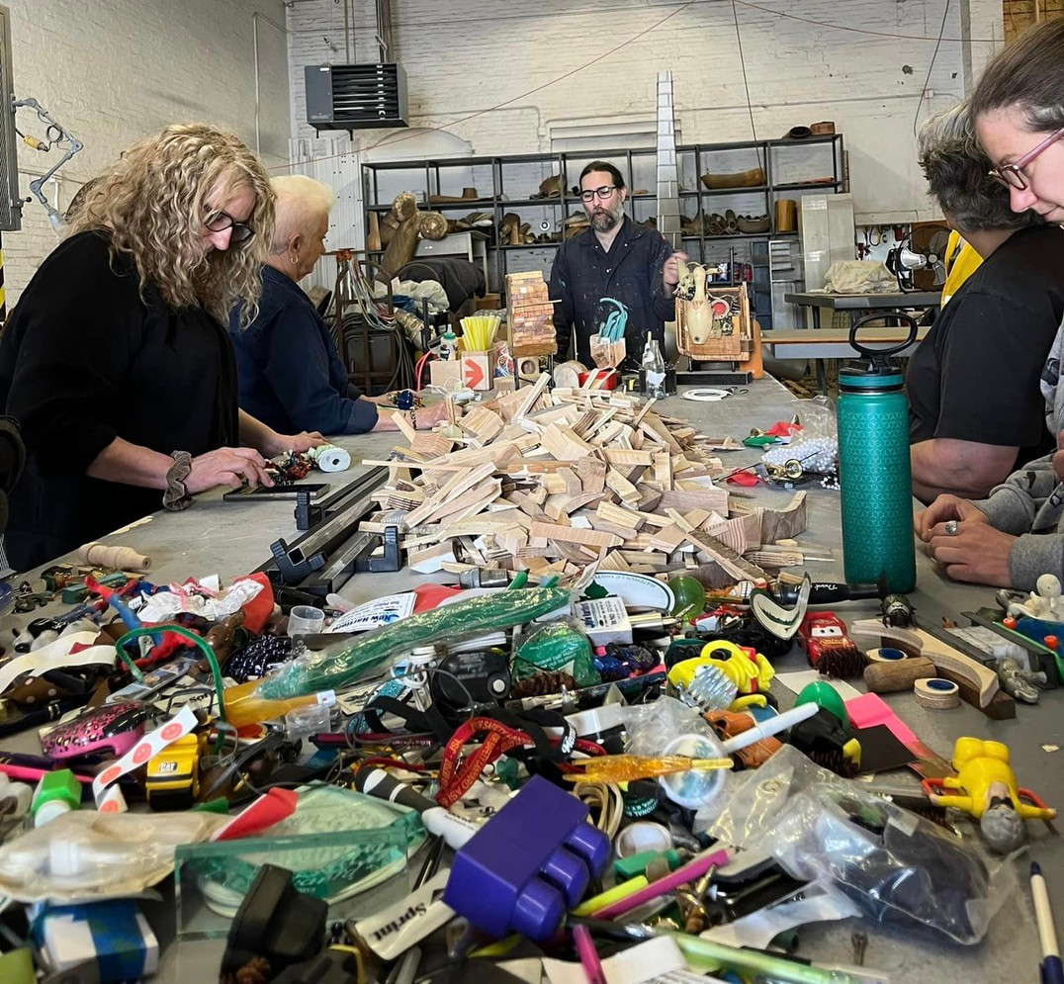
community litter cleanup.
From April to August 2024, the Trash to Treasure project supported 11 free workshops teaching participants how to create found- object artwork, centering instruction on art, environmental consciousness, reuse, and repair skills.
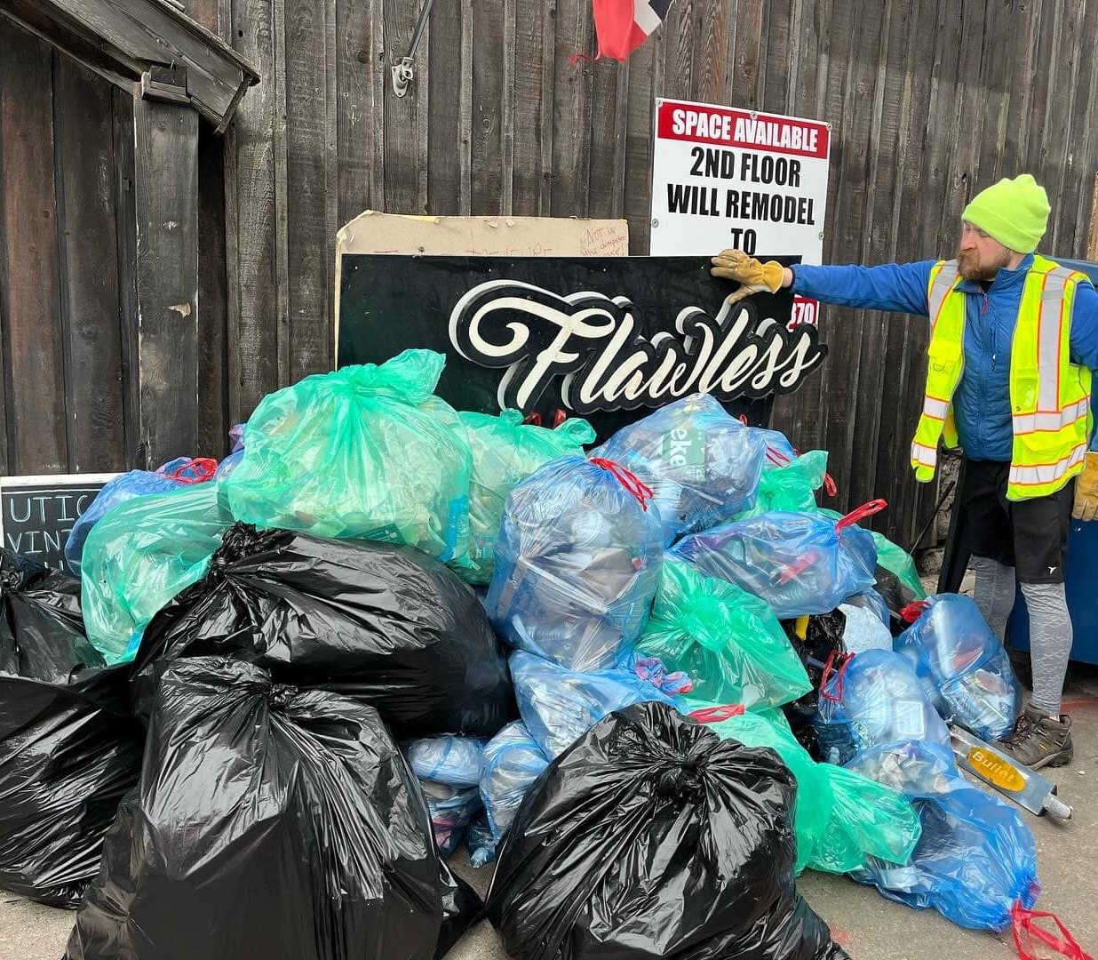
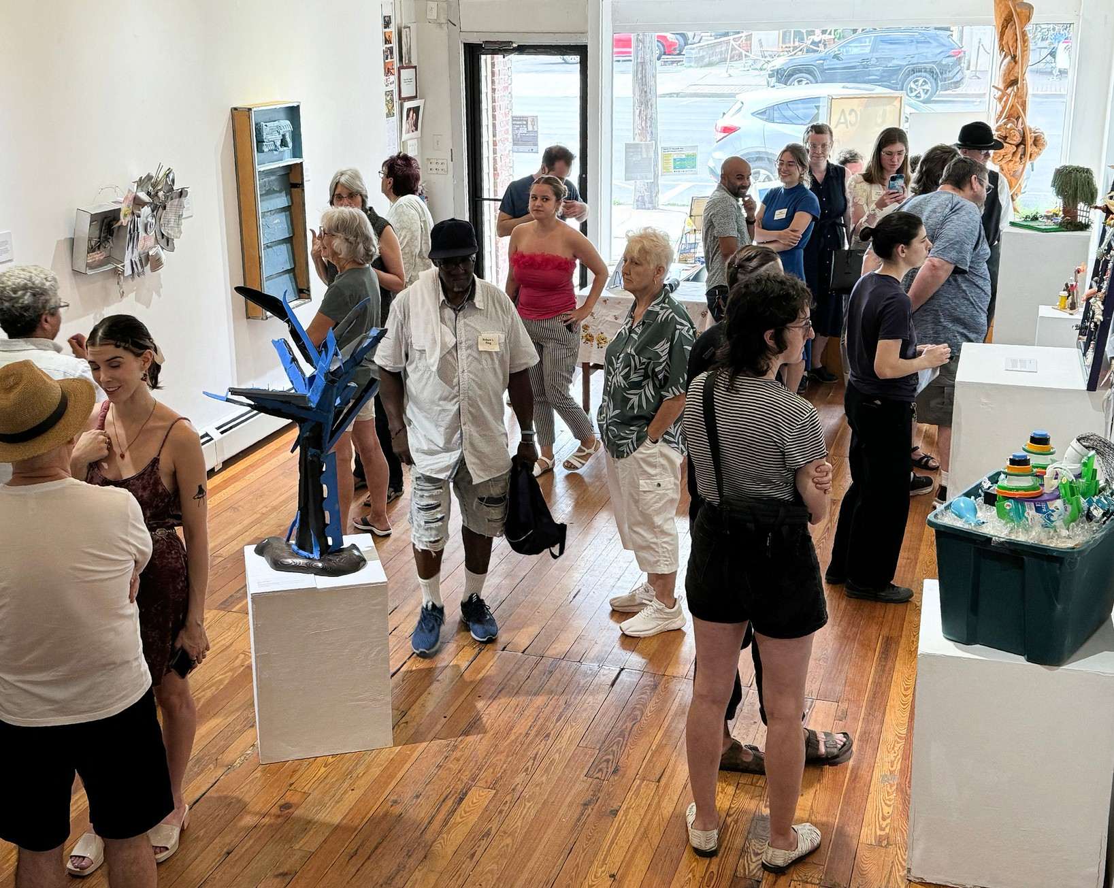
The first Trash to Treasure Art Challenge resulted in 40 volunteers cleaning up 22 sites in Utica, and 14 participating artists creating found-object artwork for inclusion in a group gallery exhibition, a three-week event held at The Other Side gallery.
Participants learning about found-object sculpture with instructor Marc-Anthony Polizzi

Utica Creative Reuse uticacreativereuse.org
Trash to Treasure exhibition of found-object artwork at the Other Side Gallery, July 2024
Earth Day Eve Community Cleanup, April 2024

Our Year in Review: March 2024 - March 2025

Looking for a Place to Call Home
In May 2024, Utica Creative Reuse received a grant of $20,993 from a donor- advised fund at the Community Foundation of Herkimer and Oneida Counties. This funding was donated with the restriction that it be used solely for general support of the operations of the organization, allowing UCR to begin the search for a Utica retail location in earnest.

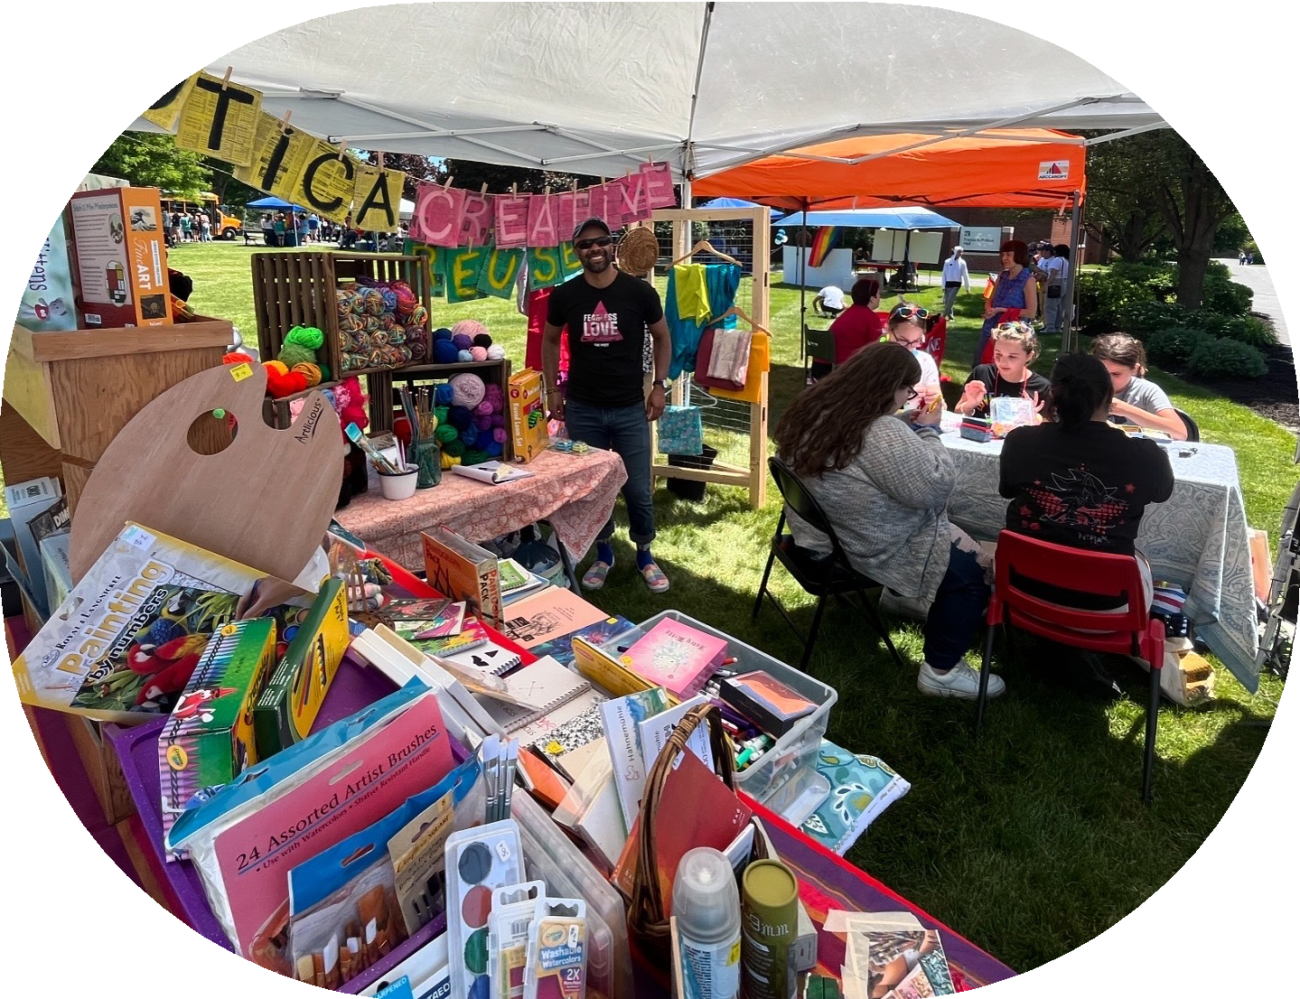
Beginning in June 2024, UCR conducted its first sales of secondhand arts and crafts supplies in a pop-up shop at the Utica Pride Festival and the Oneida County Public Market.
While continuing the search for a permanent location, UCR partnered with local organization to offer free programming at several locations in CNY.
First pop-up shop at Utica Pride Festival, June 2024 (above)
and Oneida County Public Market (below)

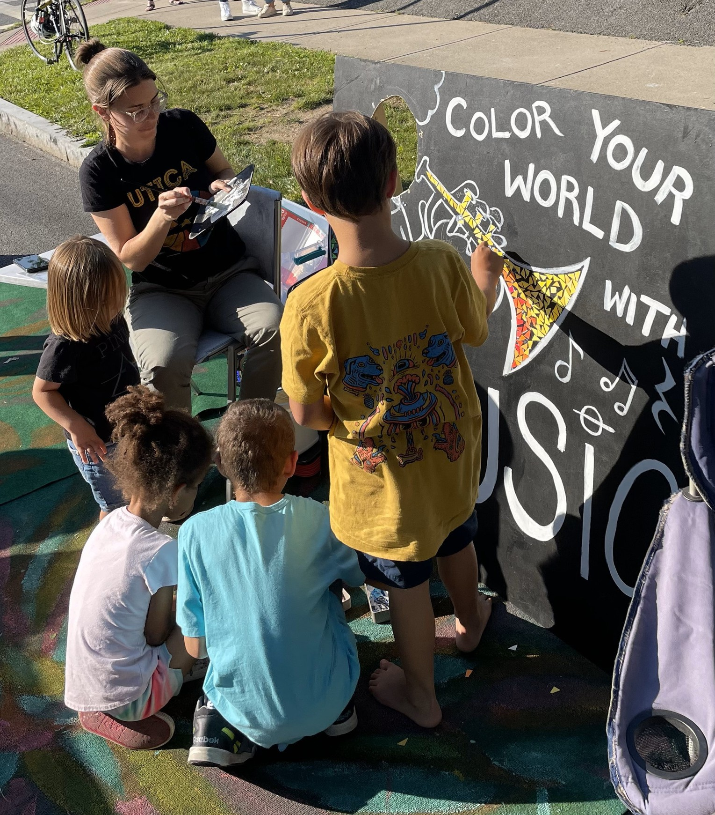
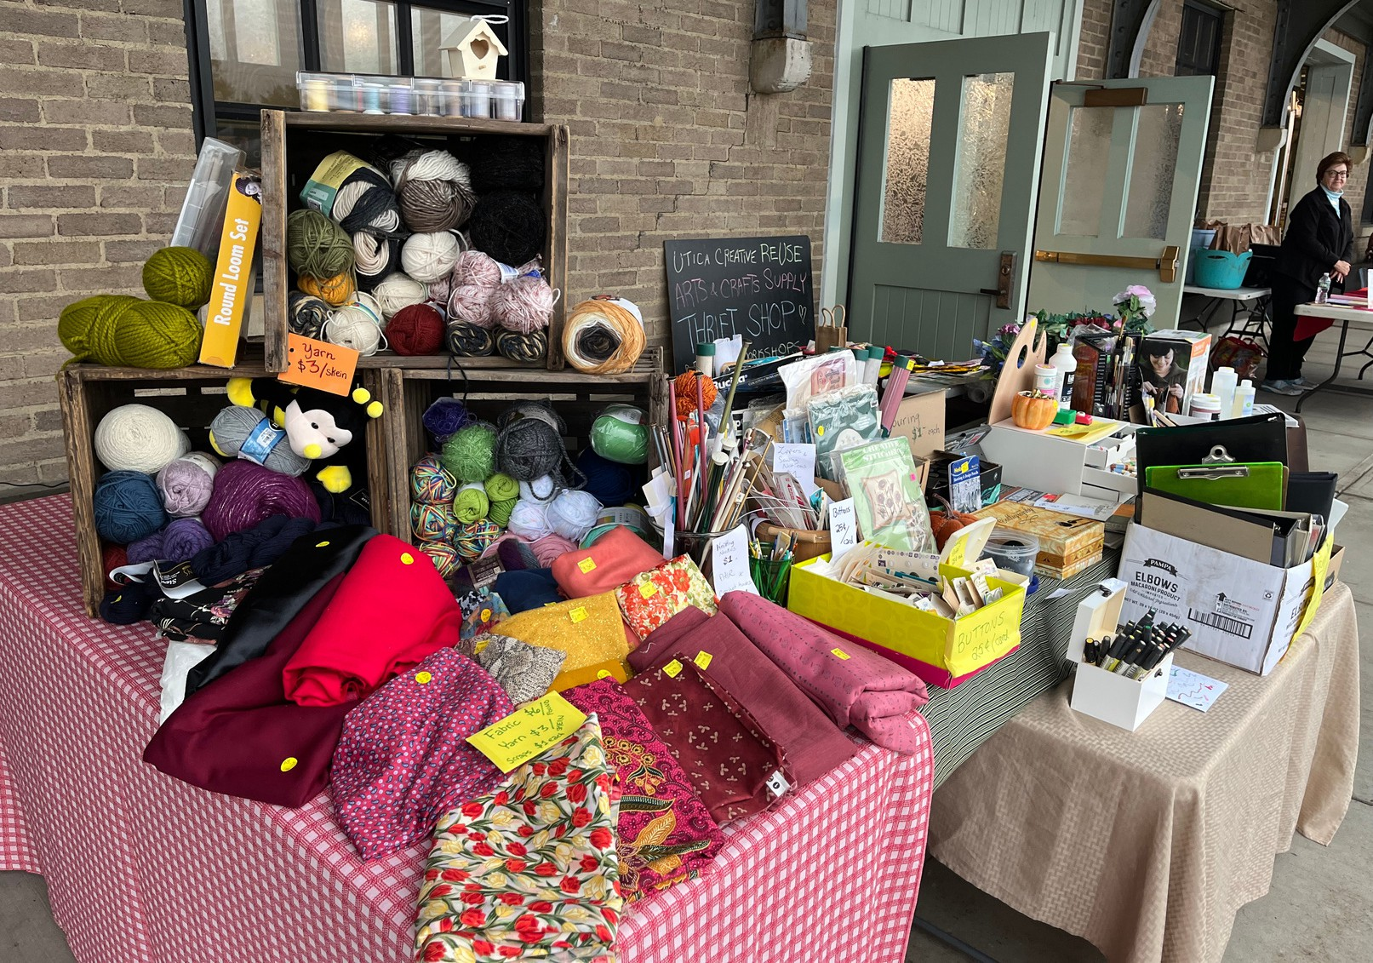
Utica Creative Reuse uticacreativereuse.org
Paper mosaic activity in the Kid’s Corner at a Levitt AMP concert in Kopernik Park, July 2024 (right)

Our Year in Review: March 2024 - March 2025

Grant Funding from NYSP2I
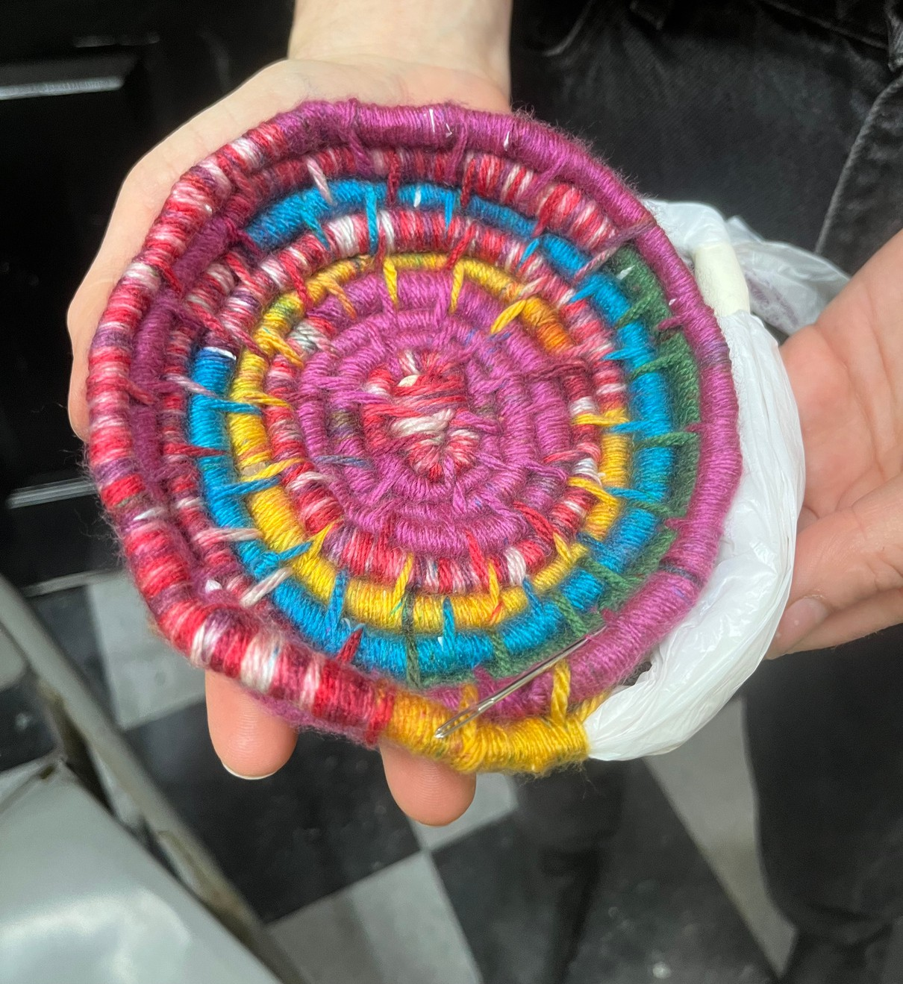
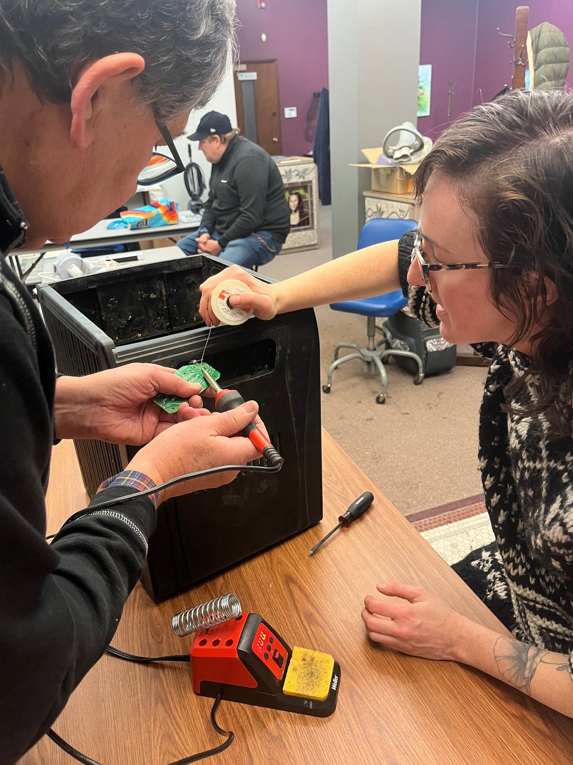
In September 2024, Utica Creative Reuse was awarded a $19,818,72 grant by the New York State Pollution Prevention Institute to conduct a year-long series of workshops centered on reuse and repair. The Creative Reuse Workshop Series included found- object sculpture and mosaic classes, a variety of fiber arts classes, and a monthly Repair Café, where community members came together to fix items in need of mending or repair.

Instructor Niki English teaching a plastic bag coil basketry class, March 2025
Thanks to the NYSP2I grant, UCR was able to retain six contractors to administer, plan, and execute the year-long workshop series, while keeping the events free to the public.

The grant also funded the creation of a series of tutorials to supplement the free classes, providing free templates online in video and print format for interested learners. The project was completed in September 2025.


Instructor Phil Szeliga at a Repair Café, helping to repair a food dehydrator
Funding for the Creative Reuse Workshop Series provided by the NYS Pollution Prevention Institute through a grant from the Environmental Protection Fund as administered by the NYS Department of Environmental Conservation. Any opinions, findings, and/or interpretations of data contained herein are the responsibility of the author(s) and do not necessarily represent the opinions, interpretations or policy of Rochester Institute of Technology and/or its NYS Pollution Prevention Institute, or the State.

Utica Creative Reuse uticacreativereuse.org

Our Year in Review: March 2024 - March 2025

2024 Mohawk Valley Gives

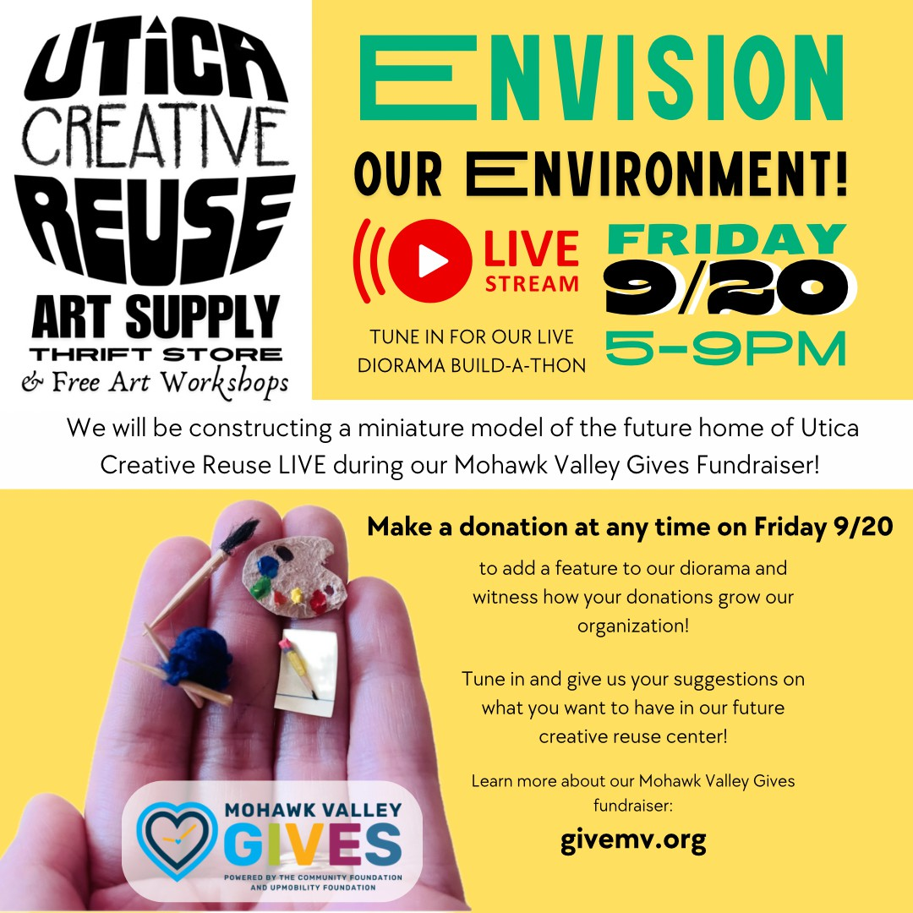
In September 2024, we participated in Mohawk Valley Gives for the first time, raising $3,849 from 42 donors toward establishing a permanent home for our creative reuse center.
During the fundraiser, we constructed a miniature diorama out of trash and recycled materials during a live-stream to illustrate to the community what a creative reuse center in Utica could look like!

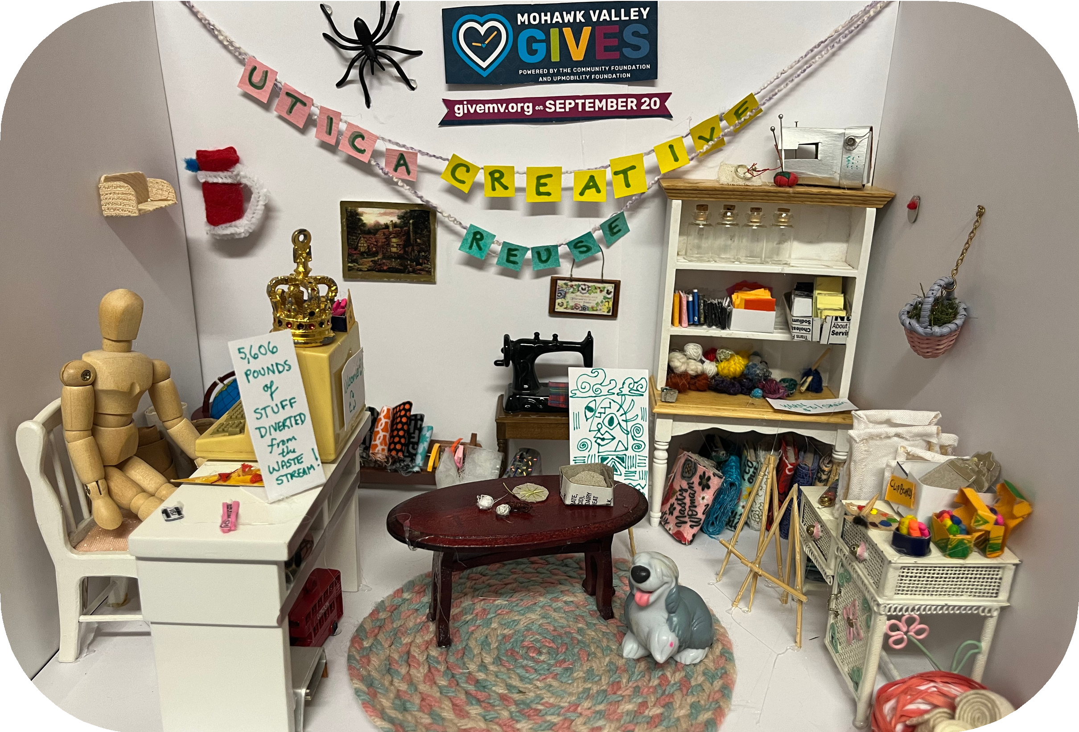

Utica Creative Reuse uticacreativereuse.org

Our Year in Review: March 2024 - March 2025

2024 Recycling Champions

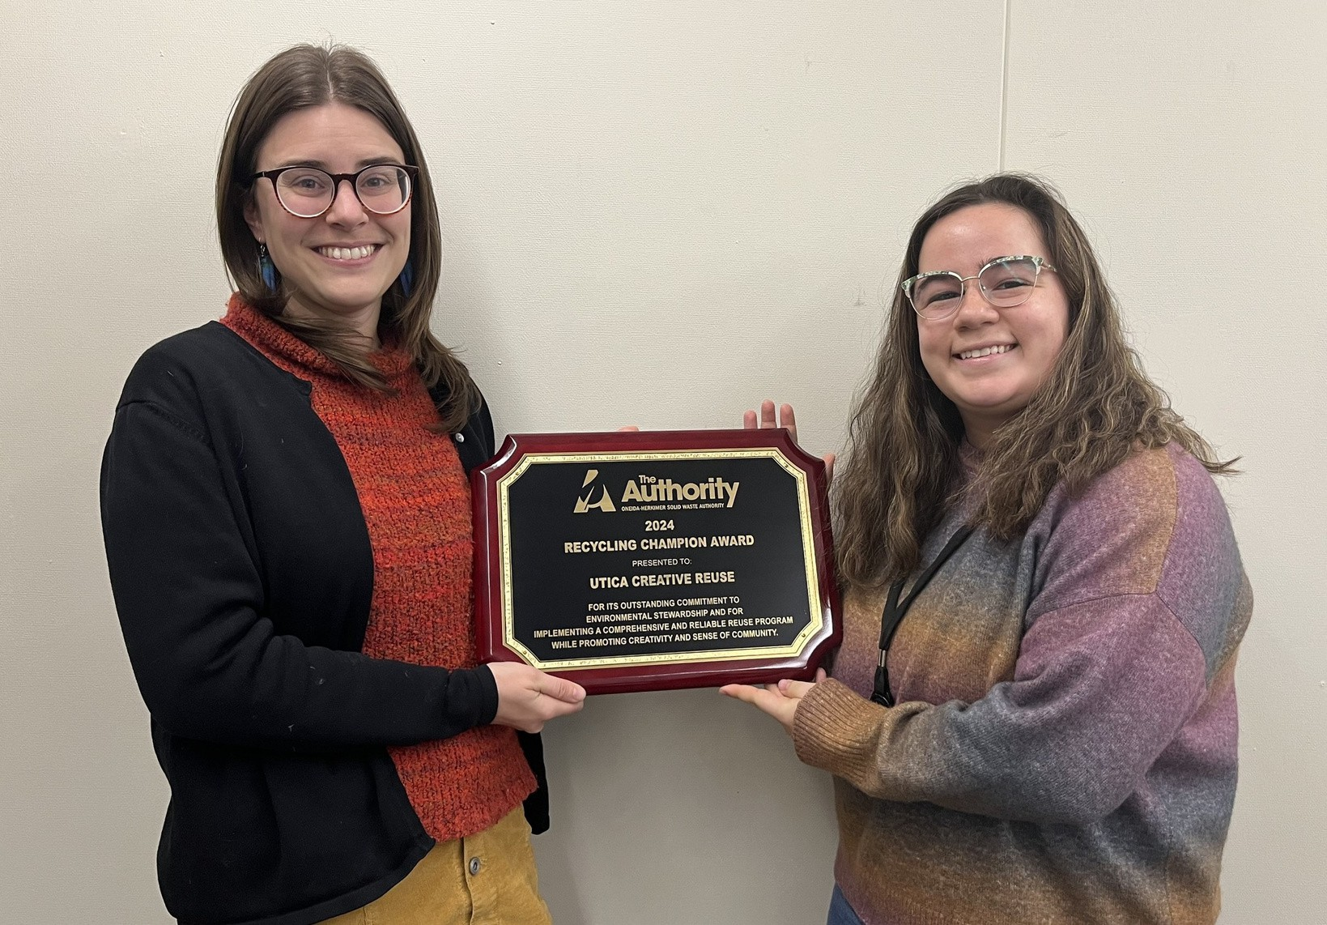
In December 2024, Utica Creative Reuse was named Oneida- Herkimer Solid Waste Authority’s 2024 Recycling Champion, in recognition of the establishment of Utica’s first creative reuse center.

Utica Creative Reuse founder Sarah Swann and Eileen Brinck, Recycling Coordinator at Oneida-Herkimer Solid Waste Authority

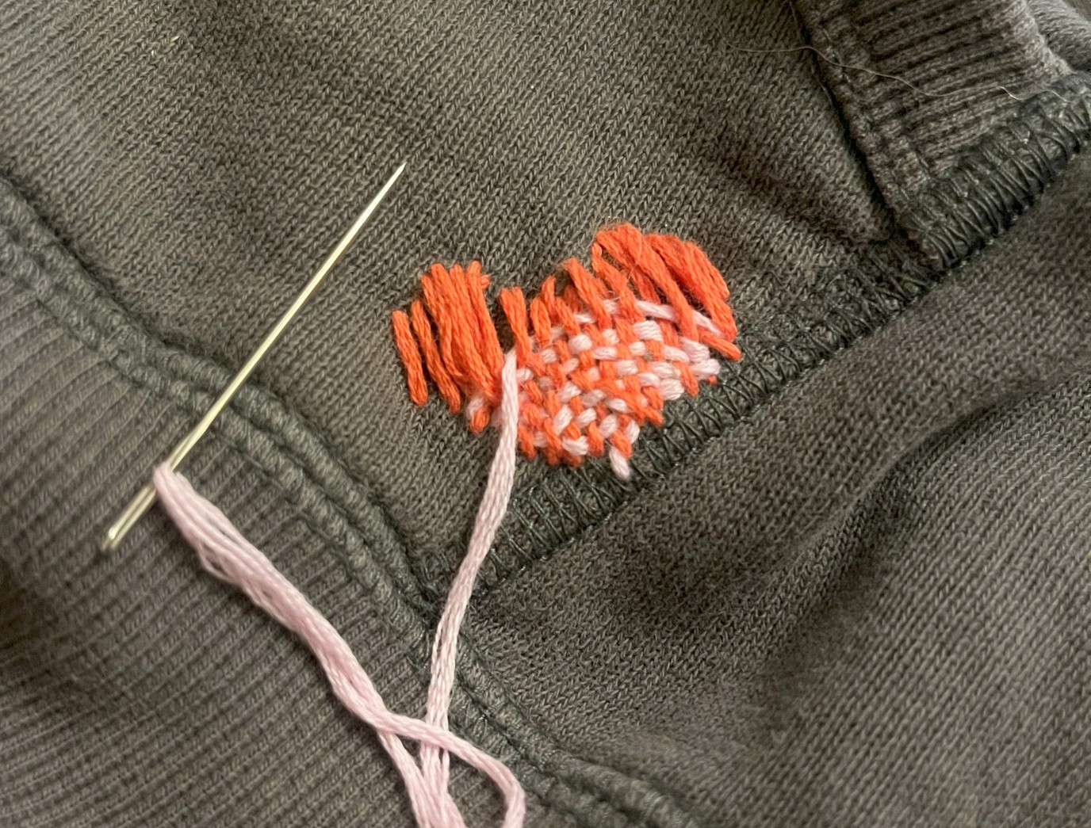

Our Year in Review: March 2024 - March 2025

A New Home for Utica Creative Reuse!
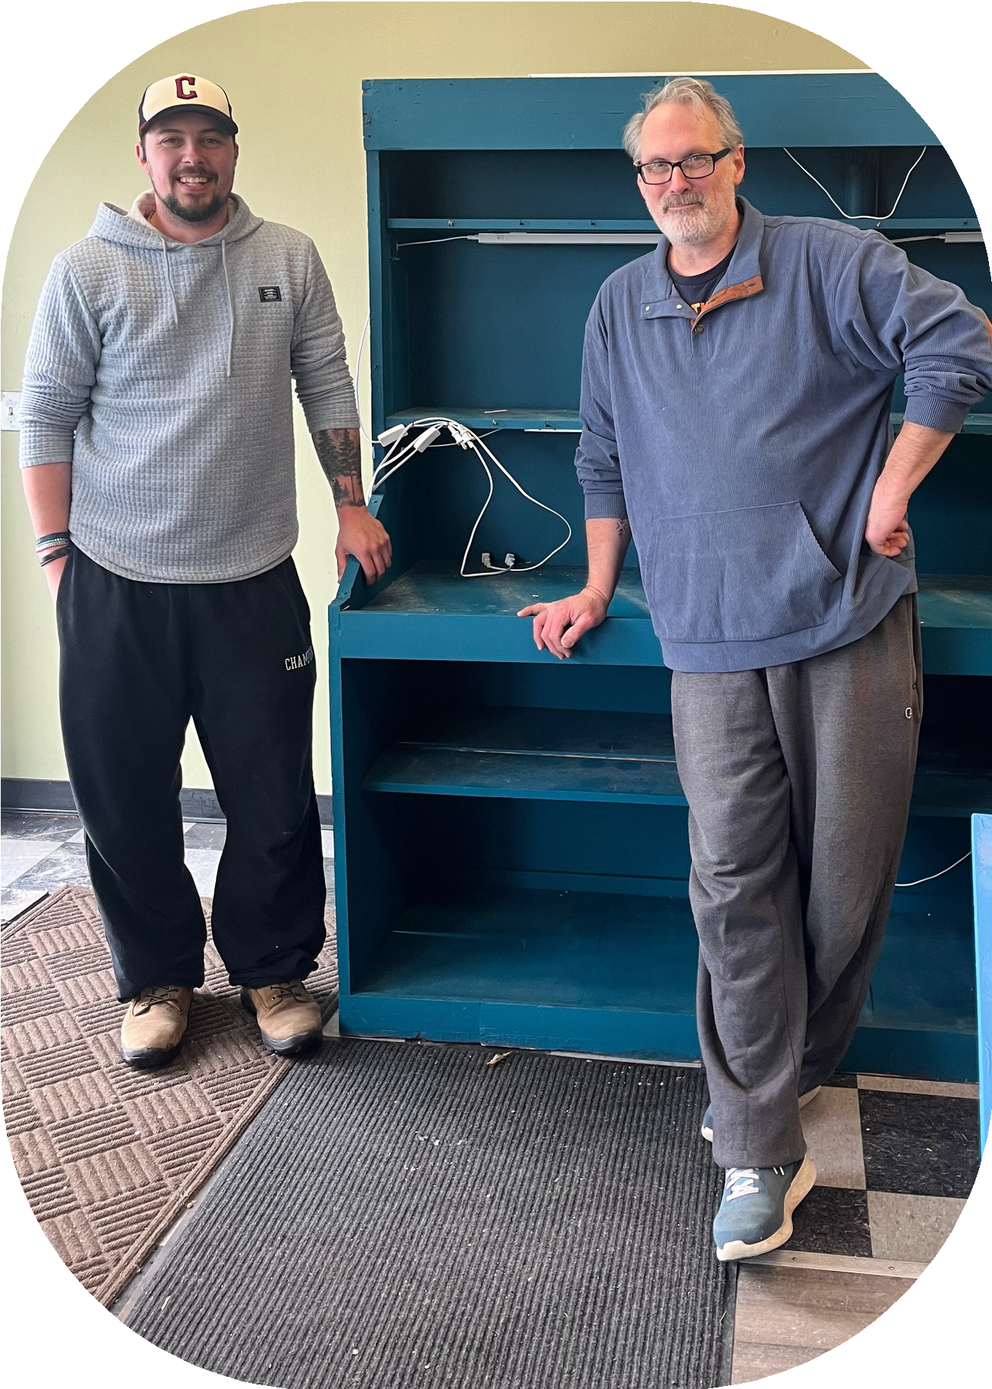
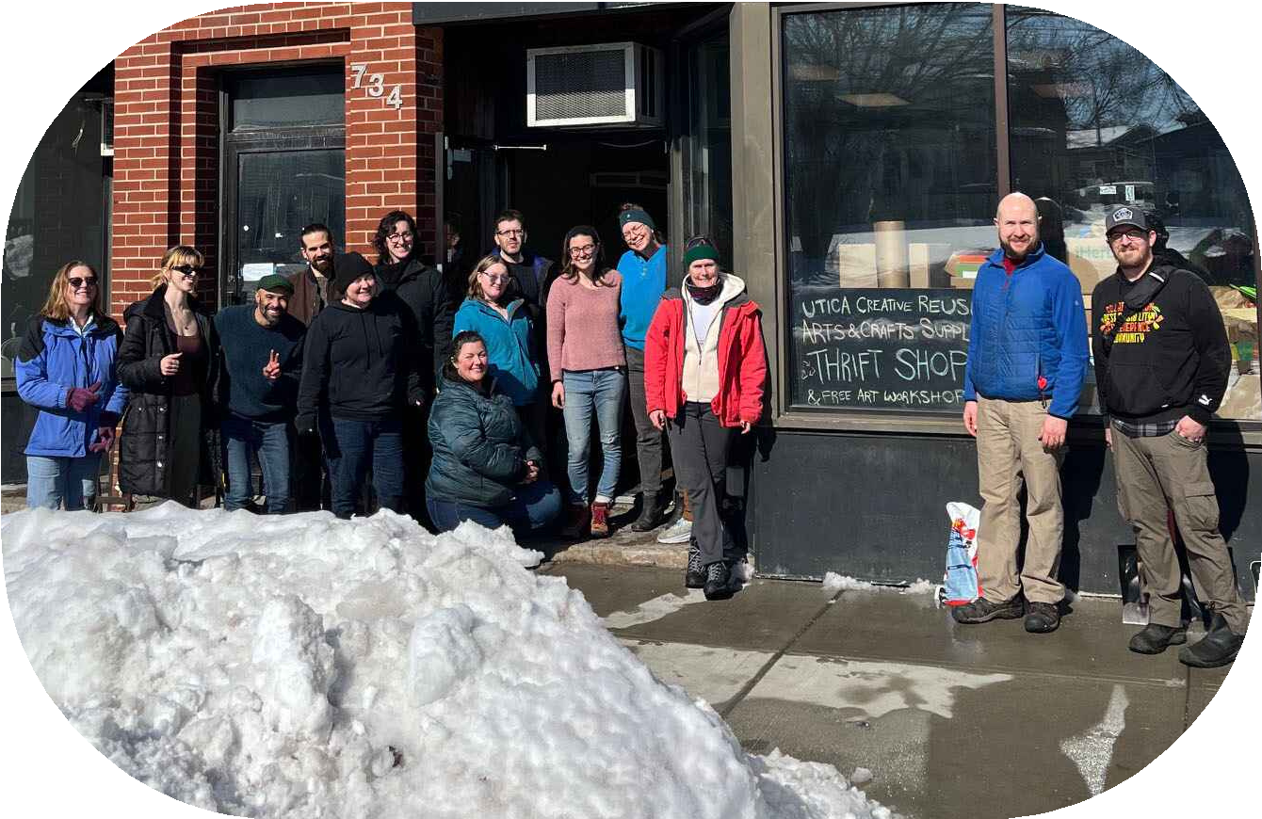
In February 2025, we secured a lease on a retail location for a creative reuse center at 734 Columbia Street in Utica, and began the process of moving in over 6,000 pounds of donated materials and supplies.

Moving Day volunteers, February 22, 2025

As volunteers worked hard to unpack, sort, and organize items in the thrift store, UCR began holding events at its new location in March 2025.

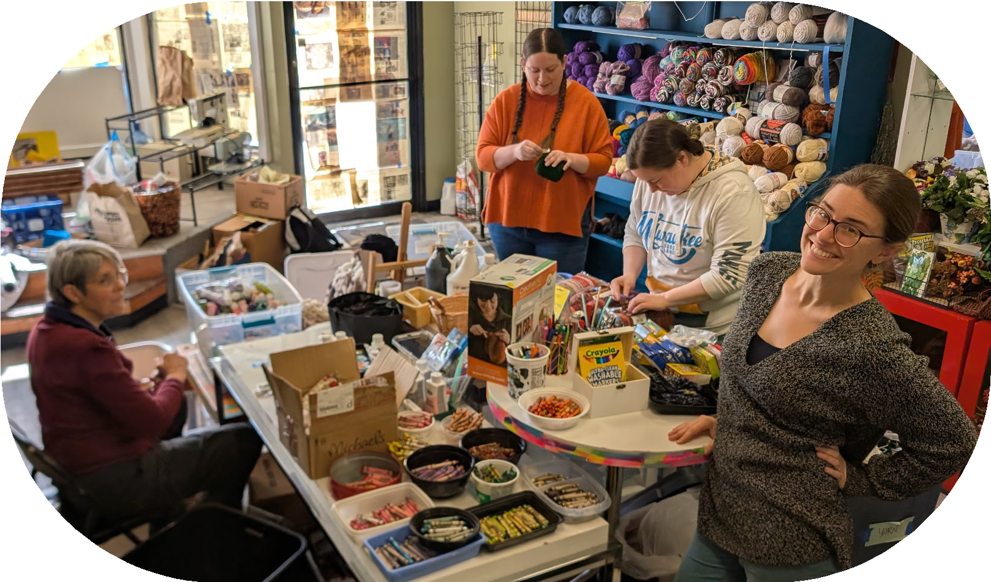
A generous donation from Rainbow Cupboard in Clinton supplied much of the furniture needed to get started
UCR’s dedicated volunteers put in many long hours sorting, organizing, and pricing donations

Utica Creative Reuse uticacreativereuse.org

FINANCIAL REPORT
March 1, 2024 - March 31, 2025

Operating Expenses

$17,973.80
General operating $1,419.12

Revenue

Building $3,829.91 Utilities $629.52 Marketing $122.51 Printing $350.70 Subscriptions $250.08 Fees $162.05
Legal $3,341.25 Equipment $3,054.04 Office supplies $44.35 Insurance $560.01 Taxes $340.68 Postage $285.85
Transportation/Travel $133.73 Contractors $3,450.00

Net assets

$37,039.28
Community Foundation Donor Advised Fund Grant $20,993.23
NYSP2I Grant Funding $3,761.25 Program Services $450.00 Gross Square Sales $3,755.83 Venmo sales $246.35
Internal Donations $2,348.13 External Donations $4,747.79
Bank interest $1.70 Misc Returns $101.00 Misc Fundraising $634.00

$19,821.18
Remaining CFDAG Restricted Funding (General Support Grant) $8,932.46 Unrestricted assets $10,888.72

Utica Creative Reuse uticacreativereuse.org

Our goals for 2025-2026
- Establish a permanent creative reuse center in Utica
- Divert usable materials and supplies from the waste stream
- Provide affordable art supplies and free (or donation based) workshops to the community
- Advance diversity, equity, inclusion, and accessibility in our arts community
- Develop a sustainable nonprofit organization
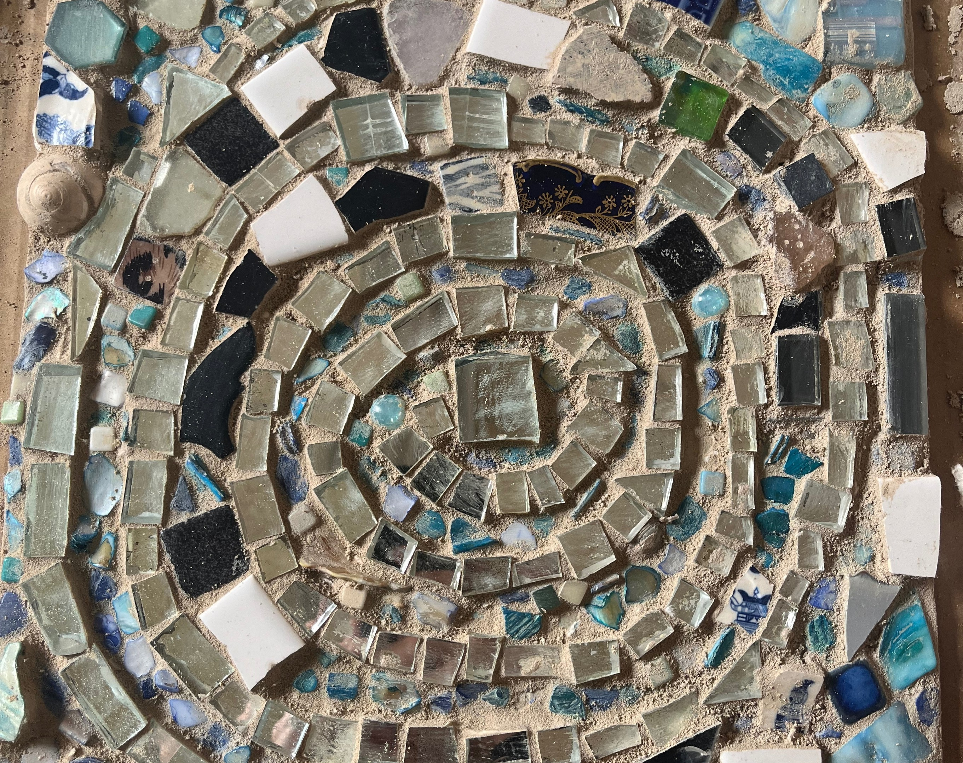
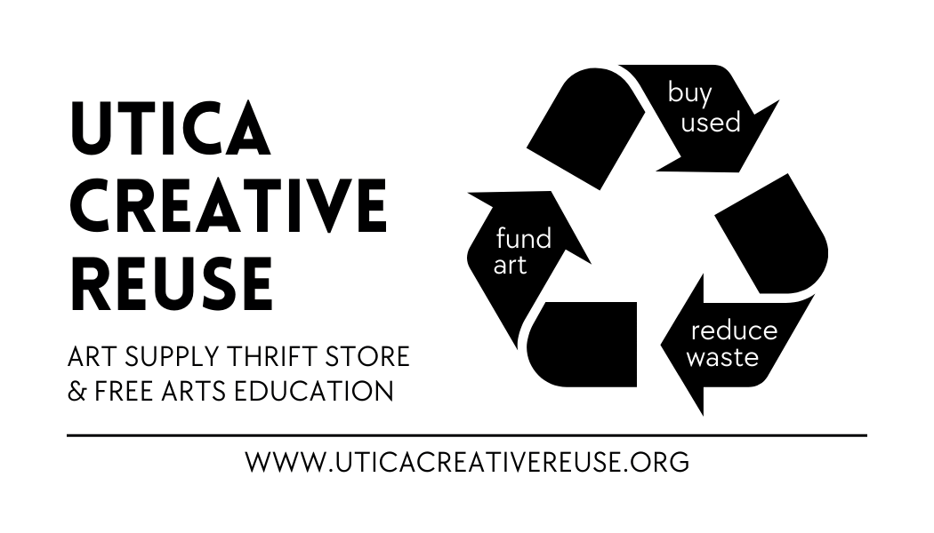

Utica Creative Reuse uticacreativereuse.org

Reaching Our Goals: Next Steps

01
Open the Utica Creative Reuse art supply thrift shop and event space at 734 Columbia Street in Utica
02 Continue to build community relationships to reduce waste, encourage emerging artists, and offer equitable access to supplies

03 Continue to generate revenue from sales, while also seeking funding support from grants and donations to support operations, events, instructors, and future paid full-time staff in support of UCR’s sustainable growth and resilience

Utica Creative Reuse uticacreativereuse.org

Thank You, UCR Volunteers!
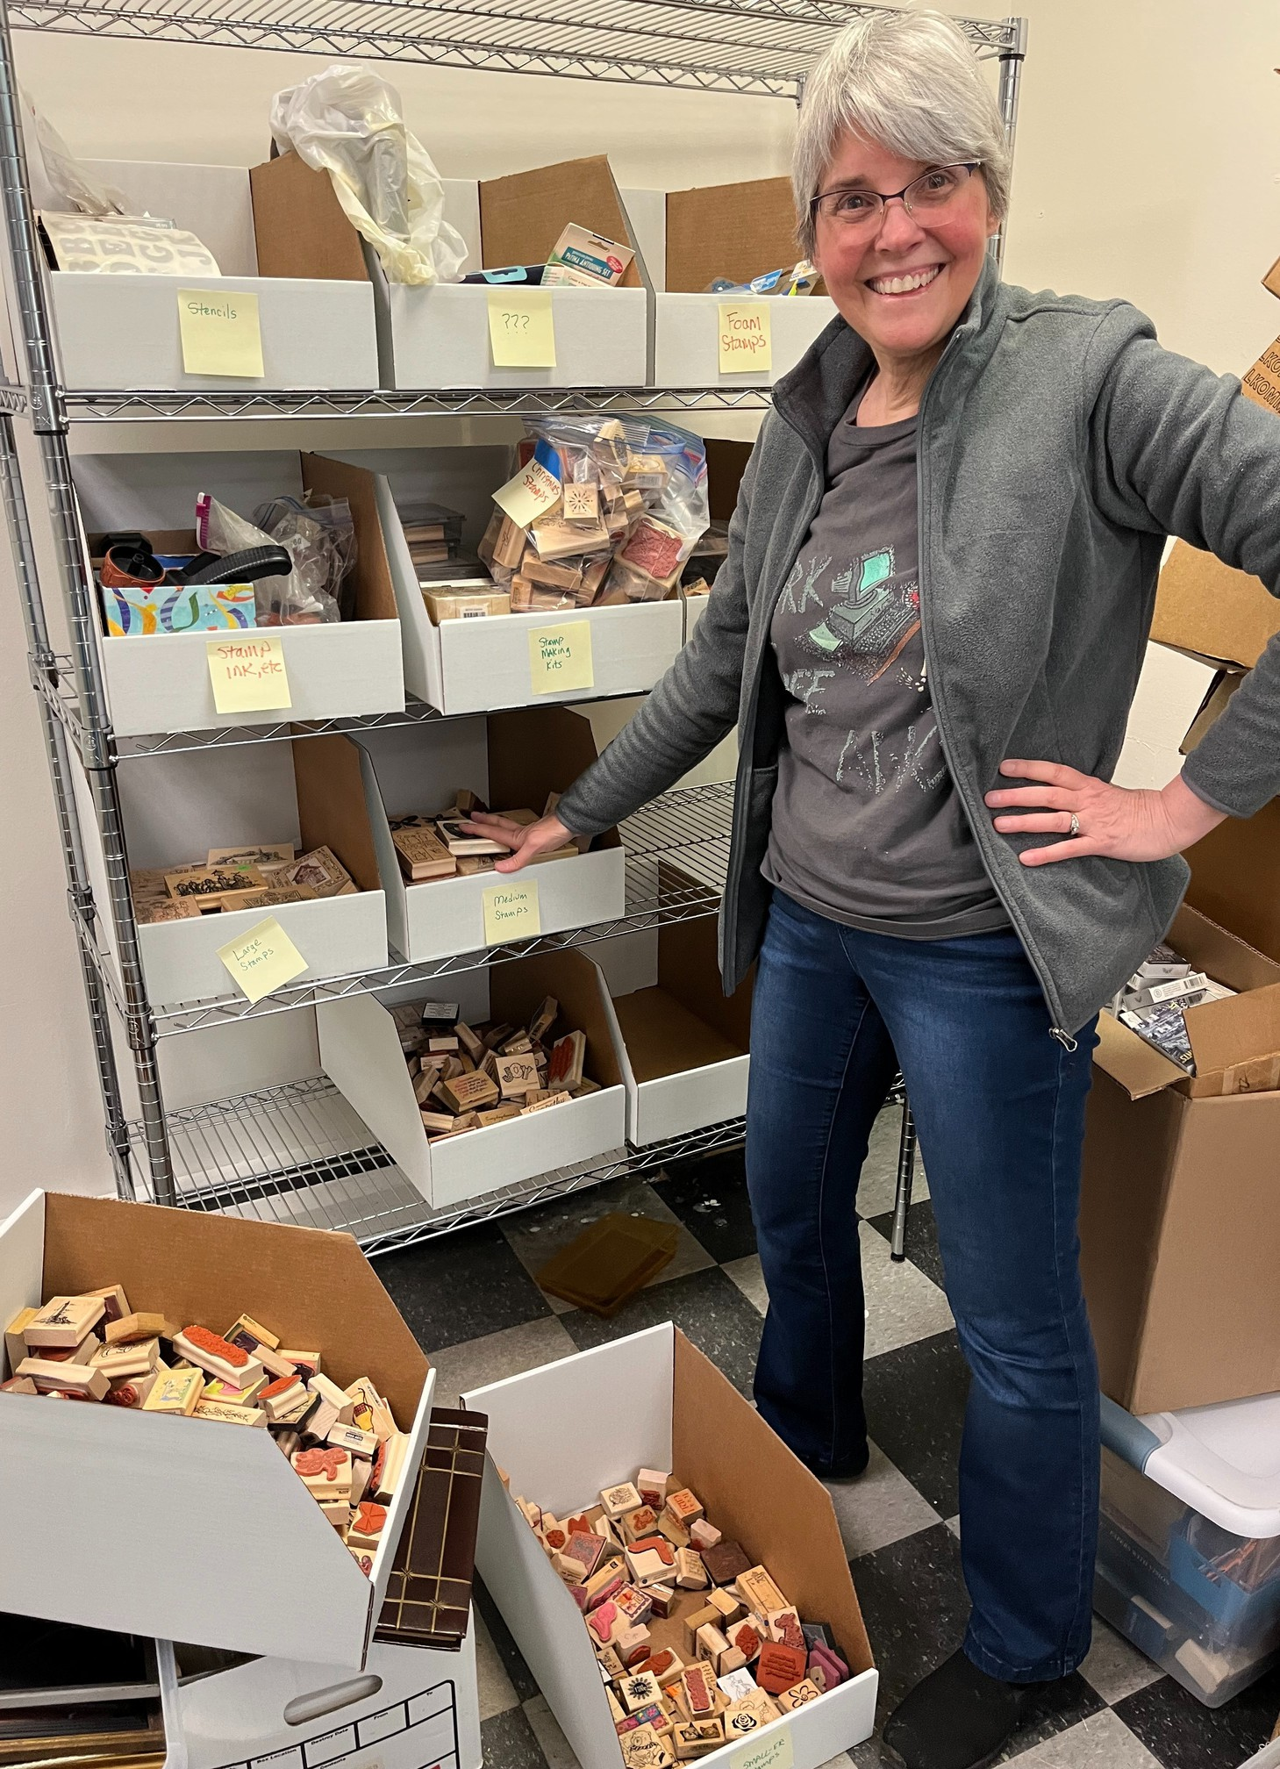
This year you donated more than 2,000 hours of sorting, organizing, brainstorming, fixing, cleaning, lifting heavy boxes, snow shoveling, picking up trash, teaching, and creating!

We wouldn’t be able to continue this work without your extraordinary talents and dedication.
Thank you for giving your time and effort, week after week, to support UCR’s mission!
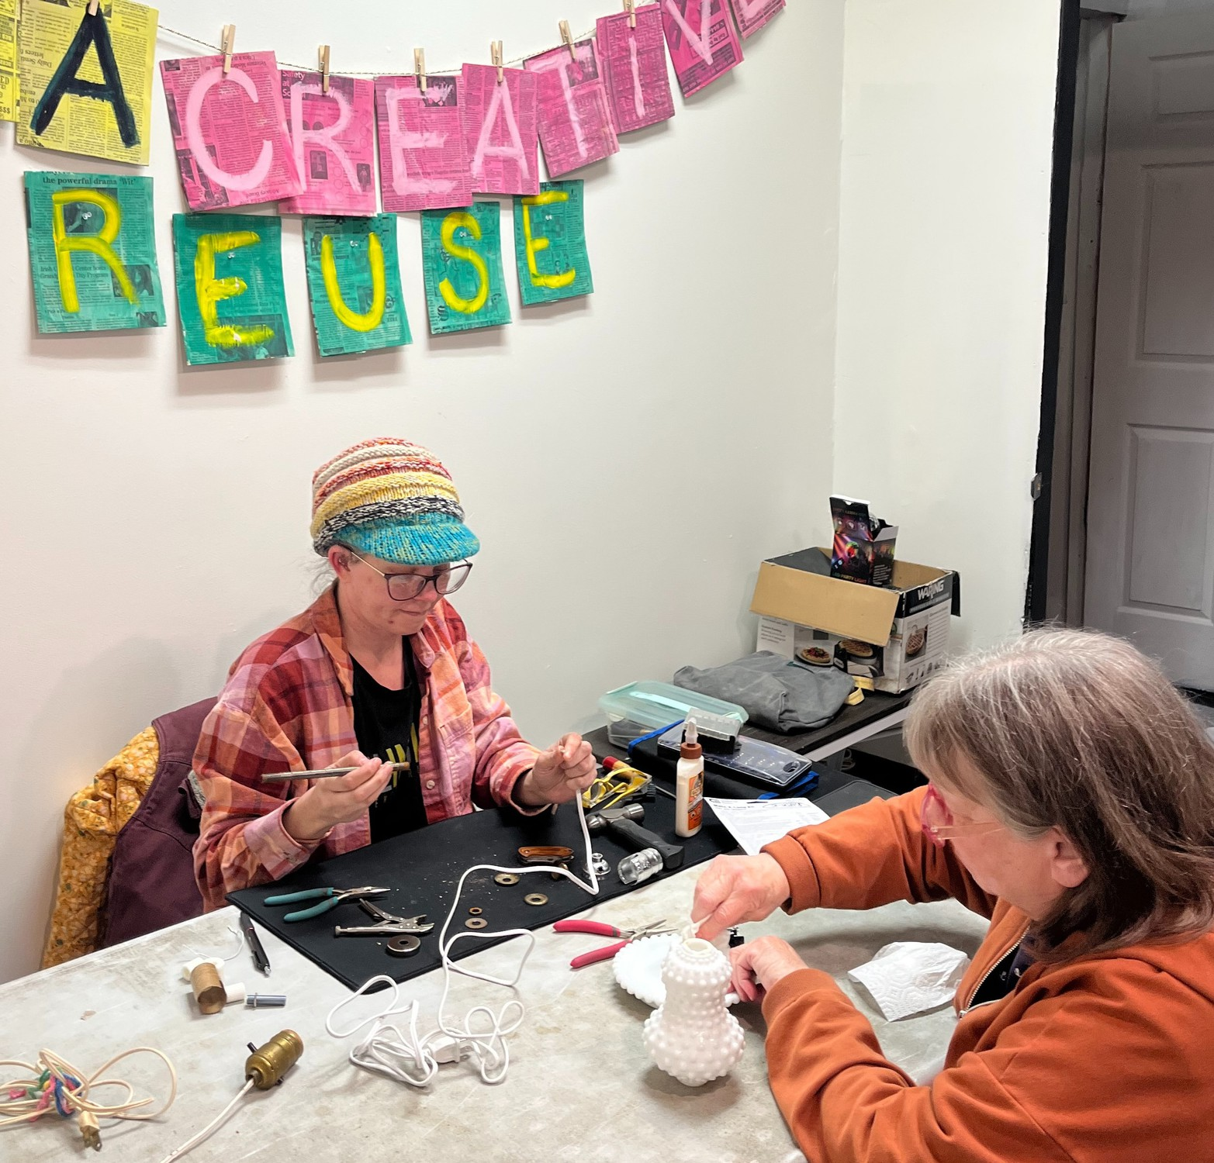
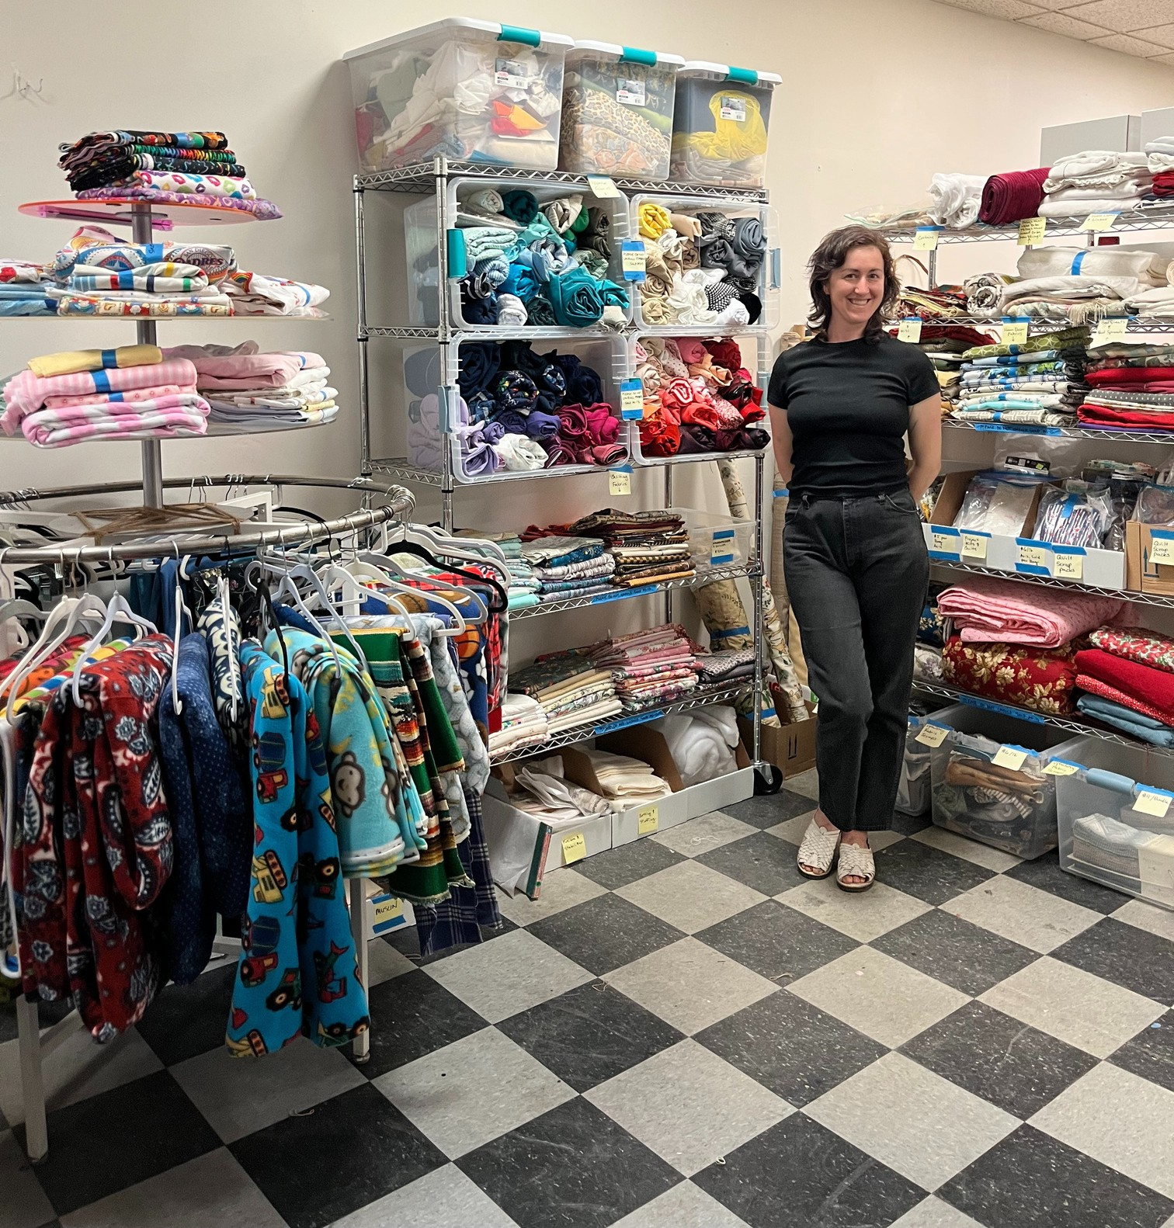

To all of our donors:
Thank you for making our work possible!
Your commitment to sustainability and support of our mission helps ensure that everyone in the community has equitable access to the arts!
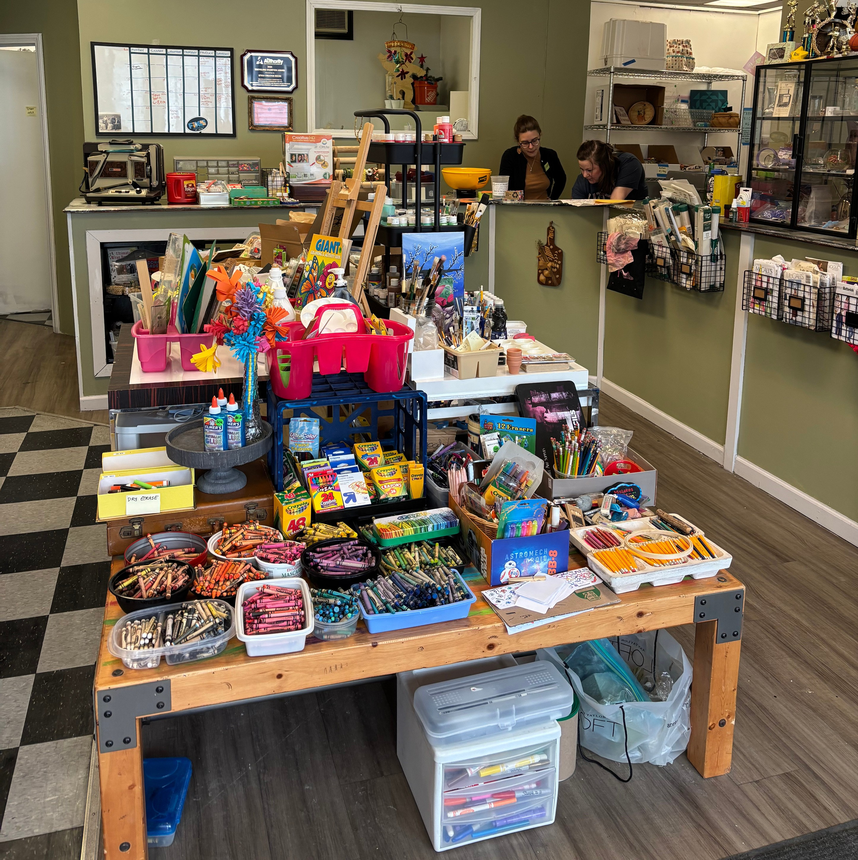

Special thanks to our community partners for their support!

Connected Community Schools The Copper Easel & Superofficial Evolve Gifts and Eco Refillery Emerson Ave Coffee
Field Table Farm Human Electronics
Keep Mohawk Valley Beautiful Levitt AMP Utica Music Series Lost Hi-Way Records
Love and Stitches Midtown Utica Community Center
Mohawk Valley Economic Development District New York State Pollution Prevention Institute The Other Side Gallery
Oneida Herkimer Solid Waste Authority Oneida County Pride Association Oneida County Public Market
Sassafras Vintage Superofficial Symeon’s
The Community Foundation of Herkimer and Oneida Counties The Copper Easel
The Tramontane Cafe Upstate Art Collective Utica Public Library Utica Vintage Club

